Foundation Practice Rating 2023
Year Two
Assessing diversity, accountability and transparency in grant-making foundations
Friends Provident Foundation
March 2023

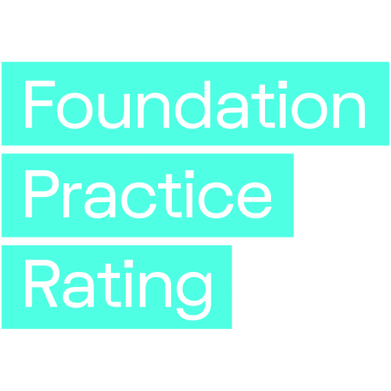

Further information
This report can be downloaded free of charge from the Foundation Practice Rating website (www.foundationpracticerating.org.uk).

Published 2023 by
Friends Provident Foundation
Blake House
18 Blake Street
York YO1 8QG
© Friends Provident Foundation 2023

About Friends Provident Foundation
Friends Provident Foundation (FPF) is an independent, endowed charity that works to build a fair economy and better world. We fund, support and invest in great projects, charities, not-for-profits and social enterprises, and use our money in line with our mission.
We are a catalyst for wider change, making an impact through continuous experimentation and shared learning. Tomorrow, we’ll continue to fund more new thinking, connect new ideas, invest our capital in line with our mission and create better systems so that in the future the economy will serve people and planet.
Connect with Friends Provident Foundation online
Website: www.friendsprovidentfoundation.org
Twitter: twitter.com/fprovfoundation
Foundation Practice Rating on Twitter: twitter.com/FpracticeRating
LinkedIn: www.linkedin.com/in/friends-provident-foundation
Facebook: www.facebook.com/FProvFoundation
Instagram: www.instagram.com/friendsprovidentfoundation/
Friends Provident Foundation Registered Charity Number: 1087053

Contents
Acknowledgements v
Foreword vi
Executive summary 1
Background 1
Year Two key findings 2
01. Background 4
The genesis of this project 5
02. How the Foundation Practice Rating works 6
Who did what? 6
A rating, not a ranking or index 7
Two key principles 8
How the criteria were defined 9
How Year Two criteria compare with Year One criteria 13
The research process 14
Converting data into scores for each pillar 15
Converting pillar scores into an overall rating for each foundation 16
03. Scope: Which foundations were assessed? 18
How foundations were included for Year Two 18
The foundations included in Year Two 19
04. Results 22
The distribution of overall Year Two scores, and scores by pillar 22
05. Analysis of results 32
High-level observations 32
Changes in foundation practice over time 36
Results for particular groups of foundations 38
Performance by criteria 43
Update on themes identified in Year One 47
New themes in Year Two 53
Examples of great practice 55
06. Reactions from foundations and FPR responses 57
07. Next steps 58
Year Three research and analysis 58
Assessing the impact of the FPR 58
Appendices 60
A. Background on ratings systems from which some criteria were drawn 60
B. The questions in the FPR 62
C. Exemption rules 74
D. Example of foundations that exhibit each item assessed 77
E. Correlations between scores and other foundation features 86
F. Foundations included in Year One and Year Two 88
G. Responses to the consultation 94
Notes 95

Acknowledgements
Sincere thanks go to the many people involved in the development and implementation of the Foundation Practice Rating:
The foundation leaders who have continued to support this work – Caroline Mason, Debbie Pippard, Edd Fry, Edward Walden, Fiona Weir, Josh Cockcroft, Julian Corner, Kirsty Gillan-Thomas, Michael Pitchford, Moira Sinclair, Sara Llewellin, Sufina Ahmad and Tim Davies-Pug.
We have also been joined by new funders and colleagues who have given generously of their time, particularly Fran Perrin and Thrisha Halder of Indigo Trust, Debbie Howitt of John Lyon’s Charity and Sam Grimmet-Batt and Hannan Ali at City Bridge Trust.
Jake Furby, Caroline Watson and Kat Chatterton at Friends Provident Foundation, who have supported this work beyond the call of duty.
Caroline Fiennes of philanthropy consultancy Giving Evidence, who has made a huge contribution to the development of this initiative. She assembled and retained an excellent team under her direction, including the author of Modern Grantmaking, Gemma Bull, and research scientist Dr Sylvia McLain, who led the research team. We thank the researchers, Hellene Karamagi, Pope Paul Oketa, Michele McGinnis, Dinah McKenzie, Sorayya Khan and Sandra Virgo for their diligence and professionalism.
Tania Mason, Matt Nolan and Ian Allsop of Civil Society Media and James at Nettl of York, who have provided expertise in once again producing the many articles, reports and web resources that form integral parts of this project.
And finally, thanks to the Trustees of Friends Provident Foundation for their enthusiasm for and continued support of this important project.

Foreword
Welcome to the second Foundation Practice Rating (FPR) report.
The concept behind the FPR is the belief that UK trusts and foundations can make a valuable contribution in addressing the many challenges facing our society today, which are even more urgent as the Doomsday clock ticks. However, research on charitable foundations suggests that we are not adequately equipped to meet those challenges. In fact, we reflect the very problems we strive to combat, for example, inequality and lack of engagement in decision-making, not listening or being accountable to those we serve, and a lack of transparency about who makes the decisions, how and why.
Despite these challenges faced by charitable foundations, we are surrounded by excellent resources, networks and expertise that advise us on how and why to do better. One of the main objectives of the FPR is to incentivise and encourage foundations’ employees and trustees to improve their practice to do better. This year’s report shows that some trusts and foundations are making progress in this regard, but there is still a considerable distance to cover before achieving even some fundamental improvements. For example, a quarter of foundations in this year’s sample don’t have a website.
After releasing the previous year’s report, we participated in conferences, sector network meetings and webinars, and wrote articles and blog posts encouraging charitable foundations, regardless of their size, to enhance their diversity, accountability and transparency. As we reflect on those experiences, we recall some of the questions we received and the conversation that developed. These included:
Why did you focus on these proxies of impact: diversity, transparency and accountability?
Trusts and foundations are complex organisations that do many things, in many places, and for a range of charitable purposes. Hence, measuring their impact effectively is challenging, time-consuming and demands appropriate methods and resources. Academic literature and popular discourse related to civil society suggest diversity, accountability and transparency are key elements, though not the only ones, that support and underpin good decision-making, fair processes and good customer care. While other assessments are typically based on finance measures, the three pillars of the FPR facilitate a more comprehensive evaluation.
Why is it so important that the foundations funding the Foundation Practice Rating also be rated?
This feature is central to the thesis underpinning the Foundation Practice Rating: our sector taking responsibility for reforming itself, drawing on standards that are already in use elsewhere and that are often applied to other social benefit organisations. Although the FPR is not a regulatory activity, the assessment aims to encourage responsibility and accountability amongst the foundations who have been assessed.
From the outset, the trustees of Friends Provident Foundation wisely stipulated that it was important that the project did not feature external experts, commentators or foundations pointing fingers at others – we are all subject to the same rules, and recognise some of the difficulties of changing our ways of working.
Why are you trying to change organisational behaviour in this way?
The financial and governance independence of trusts and foundations can shield us from scrutiny or sanction. The FPR’s aim is to increase our public accountability (through publication and open discussion) in order to incentivise improved ways of working within the dimensions of diversity, accountability and transparency. We aim to create external pressure for change, and although this is undoubtedly uncomfortable for all of us who are rated the potential benefits are an improved and more transparent sector.
We hope you find this report interesting: it contains the results of the research drawing on publicly available sources on 100 UK grant-making trusts and foundations, as well as comparisons with last year’s cohort.
Danielle Walker Palmour
Friends Provident Foundation
March 2023

Executive summary

Background
The Foundation Practice Rating (FPR) is an annual, objective, third-party assessment of UK-based charitable grant-making foundations. It looks at three important areas of practice: diversity, accountability and transparency. The project was originated by Friends Provident Foundation, and the research and assessment are carried out by Giving Evidence.
Now in its second year, the FPR assesses 100 UK-based grant-making foundations and scores them using a point-based system. It scores them on various criteria relating to their diversity, accountability and transparency. These scores are converted into a rating from A (top) to D for each ‘pillar’ (diversity, accountability and transparency); from those ‘pillar ratings’ for each foundation, its overall rating is generated.
The FPR is a ground-breaking initiative that is unlike anything else in the foundation sector, in that foundations do not opt in and cannot opt out, ensuring a representative sample of the sector. The FPR uses only publicly available information, and those included do not have any influence over the findings.
The findings are published annually with the aim of creating an incentive for foundations to improve their practices. The first set of results was published in March 2022 (www.foundationpracticerating.org.uk/results/), based on data gathered in Autumn 2021. This report covers the second year of the FPR rating and is based on data collected in Autumn 2022.
This year’s sample comprises:
- the 13 foundations funding this work (Funders Group);
- the five largest UK foundations by giving budget; and
- a random sample of community foundations and charitable foundations, as listed in the Association of Charitable Foundations’ report, Foundation Giving Trends 2021, which consists of the 300 largest UK charitable grant-making foundations.
For Year Two, the random sampling method was refined to enable better representation based on UK foundations by size (see Section 3 for more details). Some small refinements were made to the criteria used to assess the foundations, but they were largely unchanged. The criteria and guidance on how foundations would be assessed were published before the assessments were carried out. The research team then assessed and rated the practice of each foundation. Following the assessment and rating, each included foundation was sent its data to check.
This report is self-standing and includes an explanation of the FPR’s development, principles and approach. The second year’s results, based on data collected in Autumn 2022, are compared with those from the previous year.
For those readers who are familiar with the Year One approach and report, you could focus on the Executive Summary, the small adaptations to criteria (see page 13-14), and the results and analysis (Section 4 onwards).

Year Two key findings
The headline finding is that, in Year Two, seven foundations scored A overall, up from three in Year One. However, it is important to note that because the sample size is relatively small, caution must be exercised in interpreting small changes as being significant. The report examines this in more detail later.
As in Year One, the foundations scoring A overall are diverse in size and structure. They include a community foundation (Oxfordshire Community Foundation), a huge foundation (Wellcome), and a smaller endowed foundation (Blagrave Trust).
The main findings in Year Two are:
- Diversity remains the weakest pillar. This was also the case in Year One. In Year Two, no foundation scored A on diversity. In contrast, many achieved that on the two others pillars (over half achieved it on transparency). Almost half of the foundations scored D on diversity and 22 foundations scored nothing at all in this category (up from 16 in Year One).
- Scores on the three pillars are not always correlated. Some foundations scored A on one pillar, but only C or D on another. This also happened in Year One.
- Financial size is not always an indicator of a higher rating. For instance, one of the UK’s five largest foundations (by giving budget) scored only C overall. This also happened in Year One.
- Performance did correlate with the number of personnel (staff and trustees). A score of D overall was unique to foundations with 10 and fewer staff, and only one with 10 or more trustees scored D, similar to Year One.
- Similarly to last year, the included community foundations scored above average; they all scored either A or B overall.
- The majority of the included foundations in both Year One and Year Two improved rather than deteriorated. However, there is no evidence yet of improvements in the broader sector.
- The lack of websites was striking – 22 out of 100 foundations had no website. Other websites were also difficult to navigate or had limited information available, which can impact how potential applicants and external parties view the foundation. Few websites seem to have been designed with external users in mind. This is further examined on page 54-55.
- Once more, the criteria were found to be sensible. During the first year, every foundation fulfilled each criterion, and in the second year, all criteria were satisfied except for one.
- Few foundations published a qualitative analysis of their own effectiveness. They varied greatly in how much information they shared about their own effectiveness and how they involved the communities they intended to serve. There were some examples of great practice, and some foundations appeared to have analysed their effectiveness but not published it. However, foundations could do a great deal more self-analysis. This is further examined on page 55-56
The criteria on which the foundations scored the highest were:
- whether the foundation gave any information on who or what it funded (91 per cent did so);
- whether the foundation had an investment policy (90 per cent did; this is a legal requirement for some foundations, but not all);
- providing information on who made the funding decisions
The criteria that the foundations scored the most poorly on were:
- having a plan to improve the diversity of trustees or board members with numerical targets. Although 15 foundations had a plan, only one (Blagrave Trust) had numerical targets, and that was solely in relation to young people, not ethnicity, disability or gender;
- having a plan with numerical targets to improve the diversity of staff (4.7 per cent of possible points scored) and the types of characteristics in those targets (3.1 per cent of possible points scored);
- having ways of contacting the foundation concerning malpractice (4 per cent of possible points scored).

01. Background
Charities play an crucial role in modern society, and the charitable foundations that help to support them are crucial in achieving that. By taking a long-term view, foundations can respond to crises (such as Covid-19 or the rising cost of living) by increasing their giving even when their income falls and providing funding to enable important work.
Trusts and foundations highly value their independence from government, and many do not need to raise funds and are not dependent on external agencies. This enables them to operate with little transparency about what they do and how they do it. This can be a strength – it allows them to fund important but possibly unpopular causes and can unlock charitable funding from people who wish to give but are not comfortable with publicity. Foundations’ independence allows them to stay true to their missions, and gives them the ability to ‘speak truth to power’, regardless of fashions or political interests.
But such independence can also be a weakness. The sector clearly lacks diversity. Research into the trustees of foundations in England and Wales found that:
- men outnumber women 2:1;
- 60 per cent are over 65 years old;
- two-thirds are recruited informally;
- 92 per cent are white (against 87 per cent nationally).
Numerous studies and research indicates that less diverse groups make less good decisions than more diverse groups. Since foundations often seek to support and assist disadvantaged/ marginalised people, a lack of diversity within their teams could prevent them from finding, recognising or funding the most effective initiatives and organisations to support their communities. Additionally, if foundations’ materials and processes are not accessible to diverse groups, this can create obstacles to supporting these groups. This is why the FPR asses foundations’ accessibility, and the diversity of their teams and governance.
Because of foundations’ ability to do good, and because they are subsidised by the taxpayer, we all have a stake in how well they do. However, foundations lack accountability to donors or the public other than through charity law and their regulators. Beside regulators, most foundations are accountable only to their boards, which do not always reflect the population as a whole or the communities they serve.
Among other effects, this weak accountability reduces the potential for learning and improvement. Charities and non-profit organisations that seek or receive funding may well be unwilling to tell a foundation how they really feel about its practices, even if things have gone wrong or if there are important lessons a foundation might learn. They may fear that providing challenging feedback could impair their relationship with a foundation, reducing their chances of receiving funding and perhaps threatening the viability of their own organisation.
Lack of transparency about what foundations do can leave charities and individuals in the dark about how foundations work, meaning that dealing with foundations can be unnecessarily costly, which wastes scarce resources. Only 233 UK funders (including public sector funders) publish their grant data in an accessible format through 360Giving, and there are no common standards for reporting on grants, investment holdings or other activities, other than the regulatory standards. This has been addressed at various times, most recently by the Association of Charitable Foundations (ACF) as part of its Stronger Foundations initiative.
At the heart of these issues is power – independent funders are relatively powerful in the relationships in which they operate. Organisations seeking funds are less likely to be able to question the source of funds, or the legitimacy of the funder. However, in the era of big data and increasing democratisation of information (think how easy it is now to find customers’ opinions of hotels or restaurants compared to 25 years ago), these traditional relationships are shifting. Foundations are beginning to recognise that charities’ effectiveness and responsibility are based on increasing diversity and inclusivity, being accountable to the organisations that they seek to support and to society more widely, and increasing their transparency.
In 2019/20, the largest 300 UK trusts and foundations had assets of £72 billion, used to support charities, social enterprises, people in need and good causes. They made grants (and sometimes other financial instruments) that amounted to over £4.9 billion in 2019/20.

The genesis of this project
Ten UK foundations recognised the importance of diversity, accountability and transparency for foundations, and wanted to support the trust and foundation sector to improve on them, encouraging and celebrating examples of good practice, and challenging current practices where necessary. Three other foundations have since joined. The current FPR funders are listed in Section 2.
These funders commissioned Giving Evidence to develop and implement a system for rating UK foundations on diversity, accountability and transparency. The result is the Foundation Practice Rating (FPR), which provides an objective third-party assessment of foundations. The FPR uses a technique often used to increase accountability amongst corporate organisations – a published rating, created using publicly available information. FPR draws on other ratings and indices, such as the Social Mobility Employer Index.
This report describes how the FPR was developed and implemented, its Year Two results, and some patterns of changes from the Year One results.

02. How the Foundation Practice Rating works
This section describes who is involved in the FPR and their roles, the principles underpinning the FPR design, how the rating process was developed, how research was undertaken, and how the data collected about the foundations were converted into ratings.

Who did what?

Funding
The project is funded by 13 foundations:
Friends Provident Foundation
Barrow Cadbury Trust
The Blagrave Trust
Esmée Fairbairn Foundation
John Ellerman Foundation
Joseph Rowntree Reform Trust
Joseph Rowntree Charitable Trust
Lankelly Chase Foundation
Paul Hamlyn Foundation
Power to Change
Indigo Trust
City Bridge Trust
John Lyon’s Charity
These foundations, collectively called ‘the Funders Group’, meet periodically to advise on the project. The Association of Charitable Foundations also joins these meetings.

Research
The design and refinement of the rating system (including defining the criteria and research process) is led by Giving Evidence, an independent consultancy and research house. Giving Evidence works to encourage and enable giving based on sound evidence. It developed the rating system, including the criteria and scoring system, and produces the research and analysis for the ratings each year.
Giving Evidence’s research team comprises six researchers plus a research manager. Giving Evidence’s Director provides direction and structure to the team but has no influence over the data, scores or ratings. The researchers are chosen to have enough experience of charities, foundations or similar organisations and/or fundraising to understand the dynamics and perspectives of a prospective applicant, but not to know the UK foundation scene closely, so as to avoid relationships and conflicts of interest. Several of the researchers are based outside the UK, deliberately, because some prospective applicants are outside the UK and have little or no contact with UK foundations. For Year Two, these researchers all declared whether they have any relationship with any of the foundations included in the FPR: none had any.

Decisions
The Funders Group has no control over the detail of the assessment, nor the data about or ratings assigned to individual foundations, including themselves. All operational decisions are made by Giving Evidence; discrepancies on the research findings are resolved by the research team; and the scores are determined by the scoring system set up by Giving Evidence.

A rating, not a ranking or index
FPR is a rating of foundations, not a ranking.
A rating is an absolute measure of performance. In a rating system, everybody can be in the ‘top drawer’, or everybody can be in the ‘bottom drawer’.
The FPR is not a ranking, because rankings show relative performance (who is top, who is second, and so on). The FPR intends to assess what prospective applicants experience, which is a foundation’s absolute performance, not relative performance. If all the foundations they approach are brilliant, it doesn’t much matter which one is slightly more brilliant than the others; and if all the foundations are awful, it doesn’t matter who is marginally the worst. Furthermore, a ranking is a zero-sum system: if somebody rises, somebody else must fall – one organisation’s gain is at somebody else’s expense. This is not how foundation practice works.
A rating – by showing foundations’ performance on an absolute scale – gives a stronger signal for improvement than a ranking would, and is also capable of indicating the improvement of the sector overall.
Equally, the FPR is not intended as an index. An index – such as the Retail Price Index – tracks changes over time, rather than showing the absolute level.

Two key principles

Objectivity
A key principle in the FPR is objectivity. Hence the decisions are based on external sources whenever possible. For example:
- To choose the foundations to include, an existing list of foundations was used, rather than creating a new one.
- The FPR criteria were developed by drawing on other assessment tools and ratings in the private, public and non-profit sectors – such as GlassPockets’ Transparency Standard, Give.org’s BBB Standards for Charity Accountability, the Social Mobility Employer Index and the Racial Equality Index. The criteria were also subjected to a public consultation;
- Each criterion is given equal weighting within each pillar. The FPR is neutral as to the relative importance of the various criteria.
- Each pillar – diversity, accountability and transparency – is equally weighted in the overall score. The FPR is neutral as to the relative importance of the various pillars.
- The FPR assessment on foundations’ investment policies was based on the criterion used by GlassPockets that calls for foundations to have an investment policy, as well as the criteria published by the Charity Commission for England and Wales that outline what such policies should include.
Nonetheless, some scores unavoidably involved subjective judgements. For instance, one criterion asks whether a foundation had published any analysis of its own effectiveness (distinct from listing grantees or the budgets of its various funding streams). The researchers had to judge whether any particular document constitutes an analysis of that foundation’s effectiveness.

Taking the stance of a prospective applicant
Grant-making foundations create social change through the organisations that they fund. The FPR puts those organisations centre-stage. The research process was designed to mimic the experience of prospective applicant by acting as they do:
- Only publicly available data were used. These are the sources most likely to be used by a prospective applicant, i.e. the foundations’ websites and their annual reports and accounts filed with the regulator. Other materials, such as those presented at events or on social media, were not taken into account.
- A time limit was set for the research. Each researcher spent up to 90 minutes researching each foundation, a plausible amount of time that an individual might spend on initially researching a possible funder. Sometimes the information was hard to find, taking the full 90 minutes; at other times it was easy and quick to find. A prospective applicant may not take (or have) 90 minutes, so, even if the information was found and the foundation scored well on that aspect, there may be scope to make information easier to find.

How the criteria were defined

The three pillars of diversity, accountability and transparency
The FPR assesses three ‘pillars’:
- Diversity. The extent to which a foundation reports on the diversity of its staff and trustees, its plans to improve its diversity and how well it caters for people who prefer/need to communicate in different ways (i.e. accessibility). The FPR does not look at issues such as how well foundations hear and heed views from a diverse set of stakeholders to inform their work, nor what or whom foundations fund.
- Accountability. How anyone who wants to examine the work or decisions of a foundation after the event can do so, and make their voice heard.
- Transparency. Whether a potential grantee has access to the information that they need to decide whether to apply for funding, or to ask the foundation for that, or to make other enquiries.
The FPR does not examine what the foundations actually fund. It is possible that a foundation with poor disclosure and undiverse staff might fund very diverse organisations and activities. This issue may be address in future years.
The FPR evaluates whether foundations disclose information about the diversity of their staff and trustees. However, only a few foundations provided this information in both Year One and Year Two. In the second year, six foundations published a staff diversity breakdown and five published a trustee diversity breakdown. In the first year, the research team attempted to assess the diversity information reported by the foundations. However, they encountered difficulties in determining an objective way to evaluate the information. The issue was determining the basis for comparison; for example, should the racial diversity of a foundation that funds across the UK but is based in Norwich be compared to the UK, East Anglia, or Norwich? Additionally, what should be done for foundations that fund biodiversity or fund globally? Making such determinations would require subjective opinions, which the rating system aims to avoid.
Twenty-two foundations had no website at all. This is surprising, given that all charitable foundations are subsidised by taxation. Some did not disclose particular information – and sometimes this is for good reason, because of how they operate. For instance, some foundations that fund human rights work might want to avoid attracting attention – particularly to their grantees – because that may imperil them.
The rating does not imply that some ways of doing philanthropy are better than others. But it may prompt reflection about foundations’ practices, their openness and accountability. Weaknesses in internal practices may ‘spill over’ into their funding approaches.

Defining the criteria
Criteria were developed in each of the three pillars. They are listed in Appendix B, which shows the pillar for each criterion.
The Year Two criteria are much the same as those in Year One. In Year One, criteria were devised through a process that involved: discussions with the Funders Group; researching criteria used in other rating and ranking projects (UK and international); testing a subset of these criteria through a public consultation; soliciting suggestions from the general public; interviews with sector and rating experts; and several rounds of feasibility testing. The final criteria were selected only if they met both the following requirements:
- In scope. The criteria must relate to diversity, accountability and transparency. Any that did not were out of scope. For example, criteria only about environmental sustainability or relating to an assessment of a foundation’s impact or its strategy were out of scope.
- Observable and measurable. The rating process used only publicly available sources, and therefore the criteria had to relate to data that could be in the public domain. The evidence on whether a foundation met a criterion had to be measurable from the outside, and not require (for instance) interviews with staff or insider knowledge.
The criteria for Year Two were refined through a second public consultation. This ran from 20–24 May 2022. The public were invited to respond to the question, ‘What suggestions do you have about how the Foundation Practice Rating could better measure foundations’ diversity practice?’ and to comment on any other aspect of the FPR. In total, 15 responses were received.
Several respondents suggested including measures of class or the socio-economic status of foundation boards and staff. Consequently, in Year Two data were gathered about which foundations report on ‘lived experience’ for both trustees and staff, and which have targets on that. This information was not used as a criterion in Year Two: rather, it was gathered with a view to possibly adding criteria on that in future. The data that were found are in Section 4.
The exemption rule for reporting on staff diversity, and for publishing diversity plans for staff, were modified. In Year One, foundations were exempted from those if they had ten or fewer staff members. This year, the cut-off for that exemption was lowered to five or fewer staff members. This is primarily due to the fact that if a foundation has ten employees who share the same demographic characteristics, it is unlikely to be a coincidence and the foundation should have a strategy to address it. In fact, the maximum number of employees a foundation can have before the likelihood of them all sharing the same demographics by chance becomes quite small, and a number like five appears more appropriate.
The consultation produced no other implementable suggestions for changes. Hence, no further changes were made to the criteria. Several respondents suggested assessing the FPR’s effects by tracking changes in some or all of the foundations included in Year One. That could take the form of measurement or case studies. More detail on the consultation responses, and the research team’s responses to them, is in Appendix G.
Some of the FPR’s criteria are based on similar criteria used in other rating or ranking systems, e.g. GlassPockets, BBB Wise Giving Alliance, Standards for Charity Accountability, the Racial Equality Index, the Social Mobility Employer Index, and a range of reports produced by the Association of Charitable Foundations as part of its Stronger Foundations initiative.
Figure 1 (overleaf) shows two examples of the final criteria, related external benchmarks and comments from the public consultation.
The final criteria were published on the FPR website and on social media, along with advice on how foundations can achieve a high rating.
Each of the 100 included foundations was scored on the criteria, giving well over 9,000 data-points (some criteria involve multiple data-points). Each foundation was given a rating on each pillar. The pillar scores were then converted into an overall rating for that foundation. This is described in more detail on pages 15–17.

Figure 1: Examples of criteria, and related benchmarks
Pillar | Criteria | Used in other ratings or rankings tools/guidance?
Transparency | Does the foundation publish on its website any information about its funding priorities? | GlassPockets; ACF Transparency and Engagement
Transparency | Does the foundation publish any eligibility criteria for what it funds? (i.e. who as a potential recipient would be eligible for a particular grant?) | GlassPockets; ACF Transparency and Engagement

The diversity pillar also includes accessibility
In the Year One public consultation, several respondents suggested that the FPR assess how accessible foundations are, e.g. to people with disabilities. Therefore, various criteria related to accessibility have been included in the ‘diversity’ pillar, because they are about enabling a diverse audience to engage with the foundation.
A foundation’s accessibility was measured in several ways, including:
- How accessible the foundation website was. An accessible website should meet the international Web Content Accessibility Guidelines (WCAG) that are recommended by the UK Government. The WCAGs include, for example: make sure your website is accessible to people who can only use a keyboard, ensure that it is compatible with a screen reader and that web content is still legible in a single column when enlarged to 400 per cent, so that it can be used by people with visual impairments.
- Whether the foundation provided different ways for people to get in touch. According to UK Government advice, the best way to make your information accessible to everyone is to ‘make effective use of accessible communication formats’. This includes having alternative formats for people with visual impairments, such as audio descriptions, a Braille option, or, for those that have hearing impairments, using technology such as text relay, or making British Sign Language or a telephone contact option available.
- Whether the foundation provided eligibility information. Some foundations provide this kind of information solely via PDFs. However, PDFs cannot always be read easily by screen readers. Alternatives include an interactive eligibility quiz, a video explaining who is eligible and who is not, or an in-person roadshow for potential applicants and others. In short, the more formats that a foundation offers, the more audiences it can engage with and the more accessible it will be.

- Whether the foundation provided different ways for people to apply. Similar to above, a foundation was assessed on whether it offered alternative ways in which people could apply for funding, such as offline or online application forms, in-person/virtual meetings, video application, etc.
It is possible that a foundation had various methods for people to get in touch or apply for funding but they were not publicly advertised, e.g. invitation-only events. In such cases, the foundations were not given credit for that variety because a prospective applicant may not benefit from it.

The inter-relatedness of the three pillars
There are close relationships between the three pillars, so a particular criterion may relate to two or even three pillars. For example, if a foundation publishes information on the diversity of its staff, that is about diversity (encouraging diverse applicants) and transparency (who it employs). A commitment to a Living Wage could be accountability, transparency (about its practices/policies) or diversity (encouraging applicants and staff). Giving Evidence chose the most reasonable pillar for each criterion.

How Year Two criteria compare with Year One criteria
Most Year One criteria have remained in Year Two. The criteria received a favourable response in the consultation (as mentioned), and continuity aids comparisons over time. The detailed criteria and scoring scheme are in Appendix B.
Some changes were made in Year Two to ease and improve the research processes, but without material change to the assessment. These include:
- small changes in question phrasing and numbering to make a more efficient research process. In several cases, two questions were combined from Year One for Year Two;
- the addition of some free text comments for researchers. These are designed to capture richer data but are not included in the scoring;
- some re-wording to clarify the research intent, in the light of experience moderating scores from Year One.
Some other small changes were made in Year Two. Only two affect the ratings, in the diversity pillar:
- Information was collected on whether foundations report on dimensions of social class or lived experience among their staff and trustees. That information was not used in formulating foundations’ scores.
- In Year One, foundations with fewer than ten staff were exempt from questions about staff diversity plans. In Year Two that was changed to five or fewer staff. This also has the effect of aligning it with the threshold applied for the equivalent questions about trustee diversity. That change resulted in four foundations dropping a grade on their diversity score – compared to what they would have scored using the Year One rules – and those four plus another one dropping a grade in their overall score.
- The scoring for diversity was simplified for use of social media channels to provide a better balance with other channels. In effect, in Year One, foundations could get full points for using multiple social media and nothing else. In Year Two, to get credit, they needed to have social media and other channels.

The research process

Public information only
Foundations were assessed from the perspective of a prospective applicant, so the FPR only uses data from foundations’ websites and their annual reports as published by their regulator. For a few criteria the information must come from the website, such as ‘Does the foundation say who its staff are on its website?’
This may not completely capture what foundations were doing. For example, if they did an excellent job involving a diverse group of stakeholders but did not mention that on their website or in their annual report, the rating gave no credit for that.
The FPR evaluated foundations based on the information available to a potential applicant, which was primarily sourced from their websites and annual reports as provided by their regulatory body. However, this approach may not provide a complete picture of the foundation's activities. For instance, if a foundation effectively engaged with a diverse set of stakeholders but did not disclose this information on their website or in their annual report, the FPR would not have factored it into their rating.

The data-gathering process
To increase accuracy and objectivity, each foundation was assessed by two researchers working independently. The team had six researchers (plus a research manager): the foundations were assigned to the researchers randomly. Each researcher researched each question for each foundation assigned to them. Their answers were compared by Giving Evidence’s research manager. Any discrepancies were resolved by the two researchers and the research manager; in some cases, a third researcher was assigned to verify certain criteria.
The researchers gather data on:
- the criteria, such as whether a foundation has a website;
- some questions. Those are not criteria, but are used to determine the exemptions. One question is how many staff the foundation has. If it has five or fewer staff it is exempt from various criteria, such as publishing a diversity breakdown.
The data were gathered from August to mid-October 2022, and sent to the foundations in late October so that they could check them, suggest corrections and point out any omissions. The foundation’s published preferred contact method was used: that was mostly email, but for some foundations the material was posted in hard copy. Foundations had three weeks to respond. Included foundations were also offered the chance to attend two webinars in November 2022 at which they would be able to discuss the project and answer their questions.
Some foundations replied suggesting corrections. Where foundations sent or pointed to other information, the research team assessed whether this had been overlooked – e.g. if the researchers had missed a complaints policy on a foundation’s website – and whether it was eligible for inclusion – e.g. if what the foundation claimed was a breakdown of staff diversity was really that. If information was difficult to verify, two researchers were assigned to verify it. The foundations’ reactions are discussed in Section 6.

Converting data into scores for each pillar
In order to be as objective as possible, equal weight was given to each criterion: each was allocated one point (see Appendix B).

Exempting foundations from some criteria
Not all questions were relevant to every foundation. For example, foundations with few (or no) staff were exempt from the criterion about publishing gender pay gap data; and those with five or fewer staff were exempt from the criterion on publishing a plan for improving their staff diversity. A full list of the FPR’s exemption rules is in Appendix C.
As a result of these exemptions, the maximum score available within a pillar varied between foundations and was determined from only the questions relevant to that foundation.

Calculating the pillar scores
To obtain a foundation’s final score for each pillar, its actual score for that pillar was divided by the maximum possible score for it on that pillar, which gave a percentage figure. The maximum possible score was slightly different for foundations, depending on the exemptions applied, for example to invite-only foundations, or because of limited numbers of staff or trustees.
Each foundation’s score was then converted into a grade. There are four grades, from A (the highest) to D. Four grades were chosen partly because various UK public sector rating/quality assessment systems have four (e.g. Ofsted, HM Inspectorate of Prisons, the Care Quality Commission). A to D were chosen because they are easy to understand.
Each foundation’s grade on each pillar has been published, but not the numerical scores. This is to prevent a ranking being constructed from the data, which would be unhelpful, for the reasons given earlier.

Converting pillar scores into an overall rating for each foundation
Because of the FPR’s principle of objectivity, the three pillars were weighted equally to give the overall rating. A natural way to generate a foundation’s overall rating would simply be to take an average of its scores for the three pillars. However, really excellent performance requires a minimum level of achievement in all three areas, rather than just an outstanding score on one or two pillars. So the FPR does not use a straight average.
This issue had been addressed by the public sector comparators that were used. For example, in Ofsted’s ratings, if a school is rated as ‘inadequate’ on any of the four pillars of its criteria, it will be ‘inadequate’ overall: in other words, a school’s overall rating will not be higher than its lowest pillar score. The Care Quality Commission regulates health and social care provision in England. It assesses providers on various aspects, and if a provider scores below ‘good’ on any aspect, it cannot get an ‘outstanding’ rating overall.
The FPR uses a similar principle. If a foundation scores badly on any pillar, it cannot be said to be excellent. For instance, if a foundation is graded A in accountability and transparency, but D in diversity, it does not warrant an overall grade of A.
The FPR rule is that a foundation’s overall rating can be at most one grade higher than its lowest pillar score. That is, if a foundation scores D in any pillar, the best overall score it can get is C. Similarly, if a foundation scores C in any pillar, the best overall score it can have is B. The overall rating of a foundation is determined by taking the lower of:
- what the overall grade would be if the foundation’s average score from the three pillars were converted into one number, and then into a grade; and
- the lowest grade that a foundation achieved for an individual issue, increased by one.
This is illustrated in Figure 2.

Figure 2: Illustration of grading system used by FPR
Foundation | Diversity  score | Accountability score | Transparency score | Rating based on the numerical average of its pillar scores | Actual overall rating | Reason
1 | A | B | A | A | A | Lowest score (B) raised by one is the same as simple average.
2 | A | C | A | A | B | Lowest score (C) raised by one is B, which is lower than average score.
3 | B | B | B | B | B | Simple average is B, and there is no reason to lower it.
4 | D | A | A | B | C | The lowest score (D) raised by one is C, which is lower than the simple average (B). This foundation’s score is affected by its poor performance on diversity.
In fact, there were only ten foundations whose overall scores were different under the system described above than if a simple average had been used. They were mostly pulled down by their grades on diversity. Of those ten foundations, one moved from A overall to B overall by its C grade on diversity, and nine moved from B overall to C overall because of a D grade on diversity.
More details on the questions, criteria, scores and the calculation of scores are in the appendices.

03. Scope: Which foundations were assessed?

How foundations were included for Year Two
The FPR looks only at UK charitable grant-making foundations. Public grant-making agencies (such as local authorities or the research councils) are not included because they have other accountability mechanisms.
There are hundreds of charitable foundations in the UK, so a sample must be taken. The FPR assesses 100 foundations, which are:
- The foundations funding this project. The aim is not to criticise other foundations, but instead to improve the whole sector. The ‘Funders Group’ are assessed using the same criteria and process, as part of their own strategies for self-improvement.
- The five largest foundations in the UK by grant budget. These foundations dominate UK grant-making overall, and therefore have a significant impact on the areas in which they give. The UK’s ten largest foundations give over 40 per cent of the total given by the UK’s largest 300 or so foundations. Of the five largest foundations assessed in Year One, only three qualified under this criterion in Year Two.
- A stratified random subset of other foundations. These are selected from:
- community foundations for whom financial information is listed by UK Community Foundations; and
- the UK’s largest foundations, as listed in the ACF’s Foundation Giving Trends 2021 report.
Those two give a list of 387 foundations.
In the FPR sample, a fifth of the foundations are in the top quintile (by annual giving budget), a fifth in the second quintile, and so on. For Year Two, some ‘slots’ in each quintile were taken by members of the Funders Group; the other ‘slots’ were filled by random selection from the groups (a) and (b) above.
The Year Two approach differs from Year One, which involved selecting a sample of 100 foundations that included the 13 Funders Group foundations and the five largest foundations, with the remaining 82 chosen randomly from these two categories. However, that approach resulted in over-representation of the larger foundations, as the random selection was based on quintiles with an unequal distribution. In contrast, the Year Two approach ensures that the quintiles are of equal size, thus avoiding over-representation of larger foundations.
In response to feedback on Year One, foundations were this year offered the option to opt in to the FPR. Such foundations would pay a small fee to cover the research work, their results would be published, but they would be removed from the main analysis to avoid the selection effect skewing the results. One foundation did so: the KPMG Foundation. Its results are included in this report, but it is not included in the main data about our sample of 100 foundations.

The foundations included in Year Two
The 100 foundations included in Year Two collectively had:
- net assets of £68.1 billion, compared to £44.4 billion in Year One;
- annual giving of £1.8 billion, compared to £1.25 billion in Year One; and
- an average pay-out rate (i.e. the amount given annually as a proportion of assets) of 2.6 per cent, compared to 3 per cent in Year One.
Twenty-eight foundations were included in both years: 10 from the Year One Funders Group; one selected randomly in Year One that joined the Funders Group in Year Two; three large foundations that were in the top five by size in both years; 14 randomly selected for inclusion in both years. Appendix F lists the foundations included each year, indicating which foundations were included in both years.
Figure 3 provides further information on the Year Two sample.

Figure 3: Composition of the Year Two sample
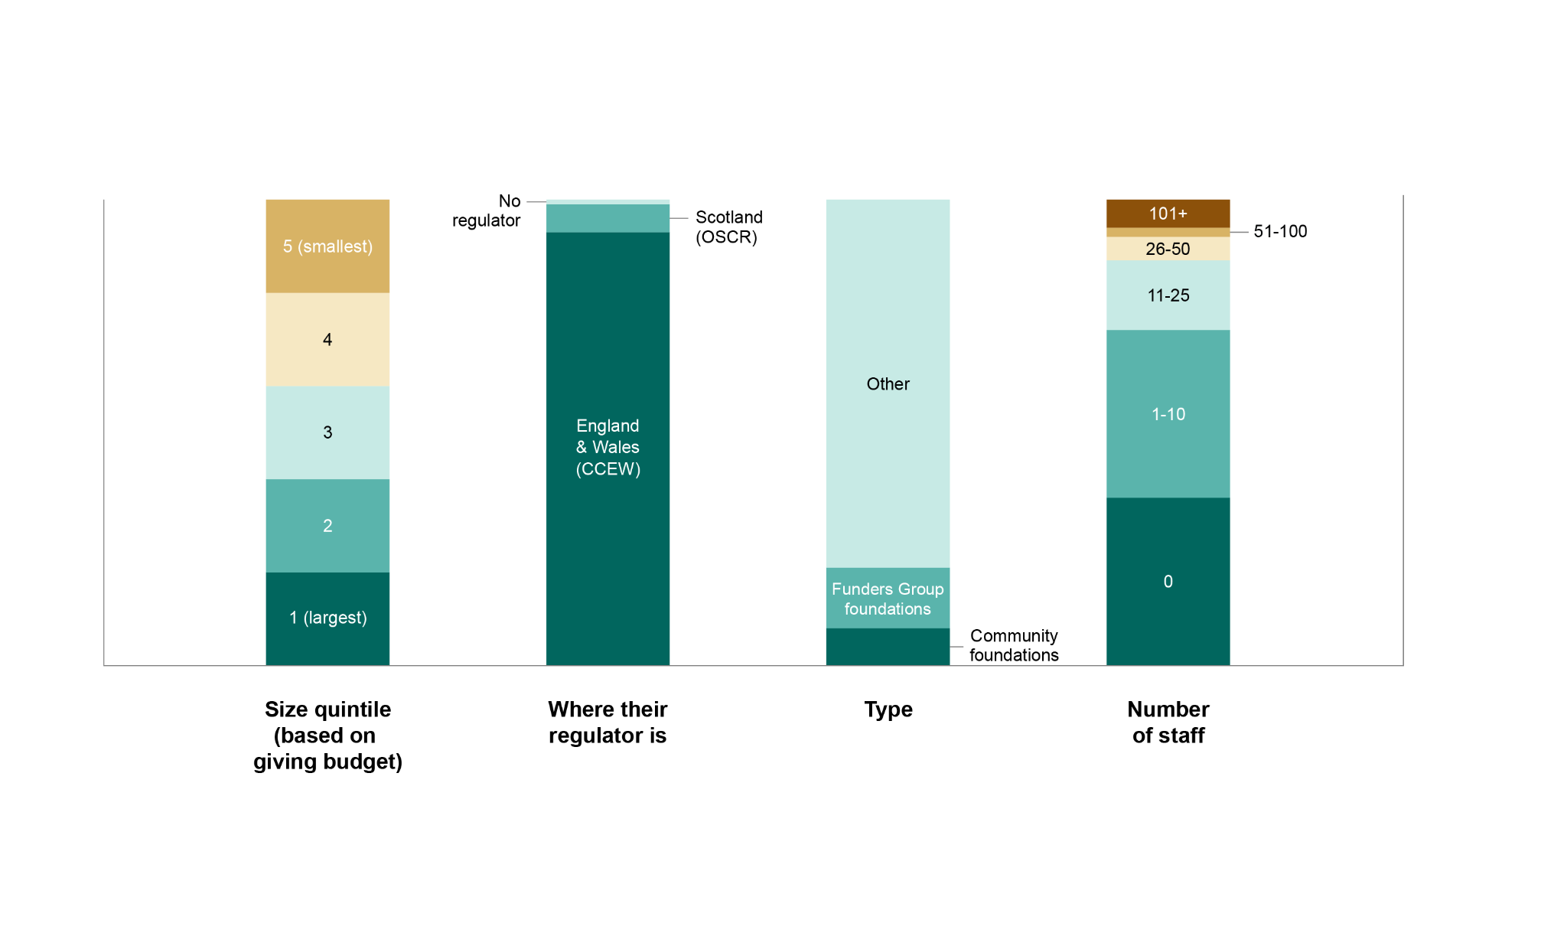
Figure 4 shows the location of the headquarters of the Year Two foundations. None was in Wales or Northern Ireland, and the presence in English regions was dominated by London.
Figure 4a: Location of foundations included in FPR Year Two
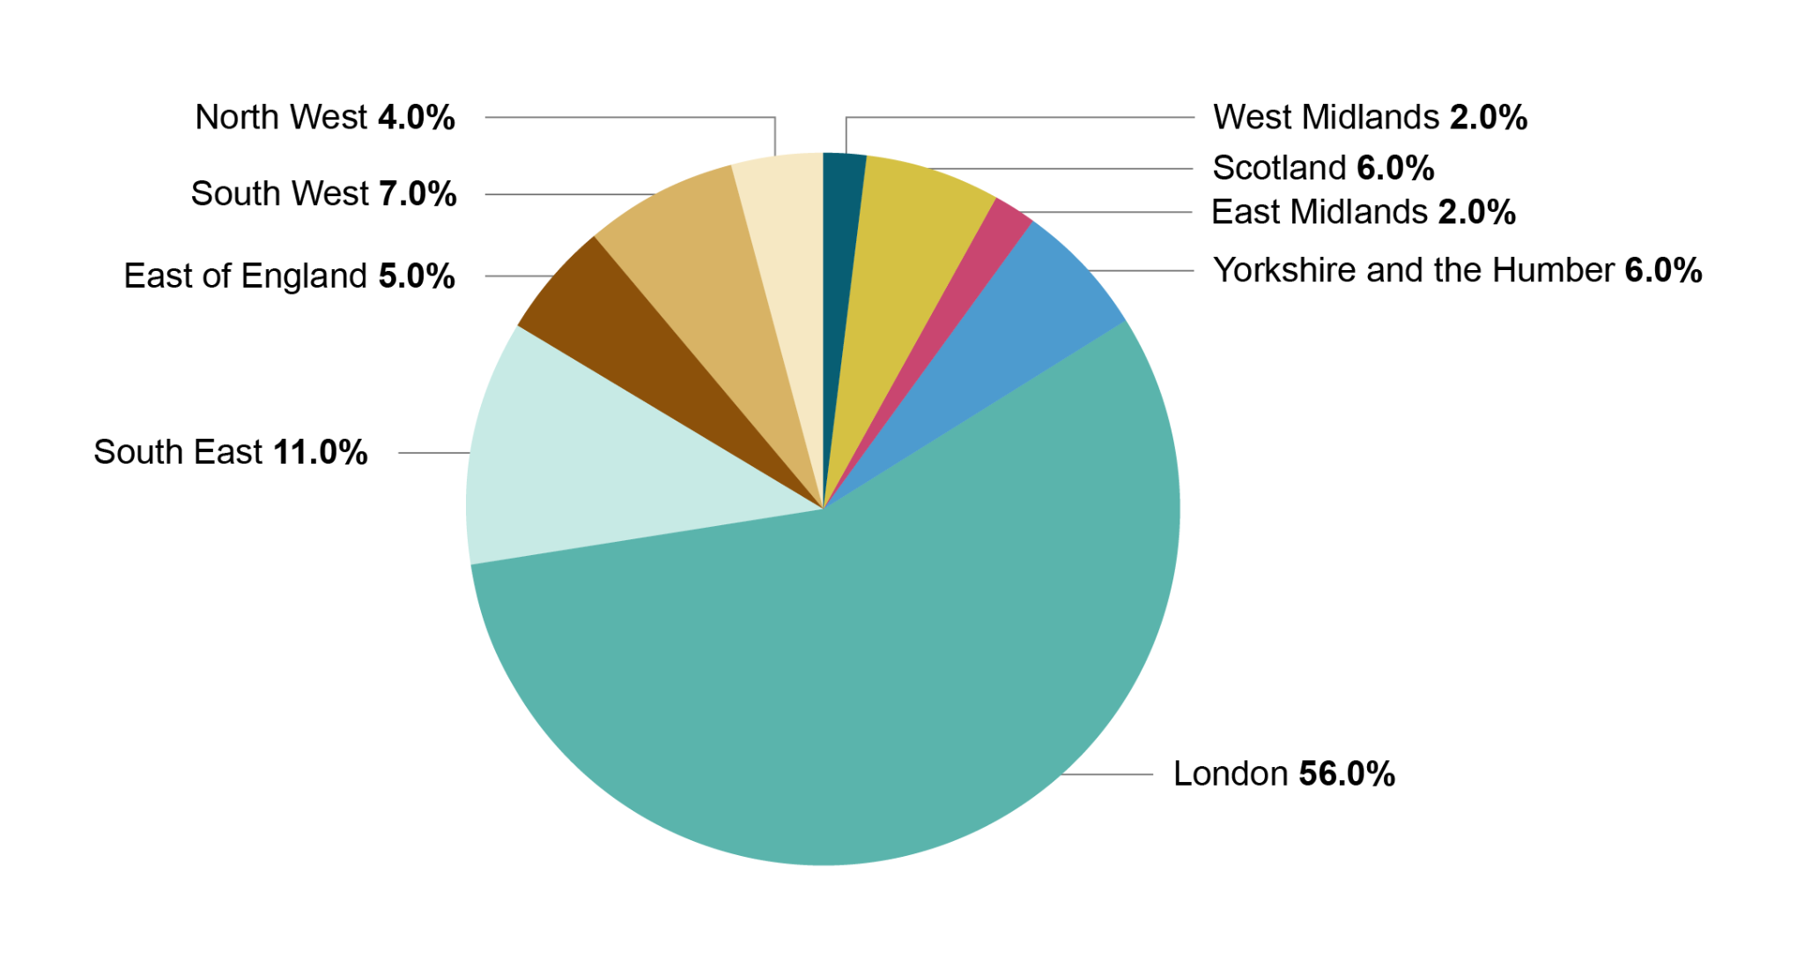

Figure 4b: Location of foundations included in FPR Year Two
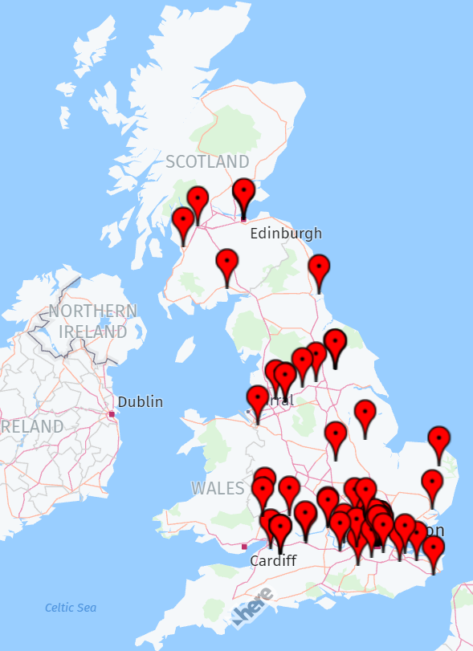
In future years, the foundations included in the FPR will again be:
- the Funders Group;
- the five largest foundations by giving budget;
- a fresh sample of other foundations drawn at random.
This means that any foundation included this year may or may not be included next year (unless they are in the Funders Group or are one of the five largest).

There are advantages and disadvantages to this approach. One advantage is that it increases the incentive for all UK foundations to improve, since they know that they could potentially be rated. Additionally, the results should provide a more accurate representation of the sector's progress overall, rather than just the group of foundations previously included. However, a disadvantage is that foundations included in this year's assessment but not in the next will not have the benefit of continuity from repeated assessments.

04. Results

The distribution of overall Year Two scores, and scores by pillar
Figure 5 shows the distribution of ratings (A–D) in each pillar, and for each foundation overall.
Figure 5: Number of foundations achieving each rating in Year Two
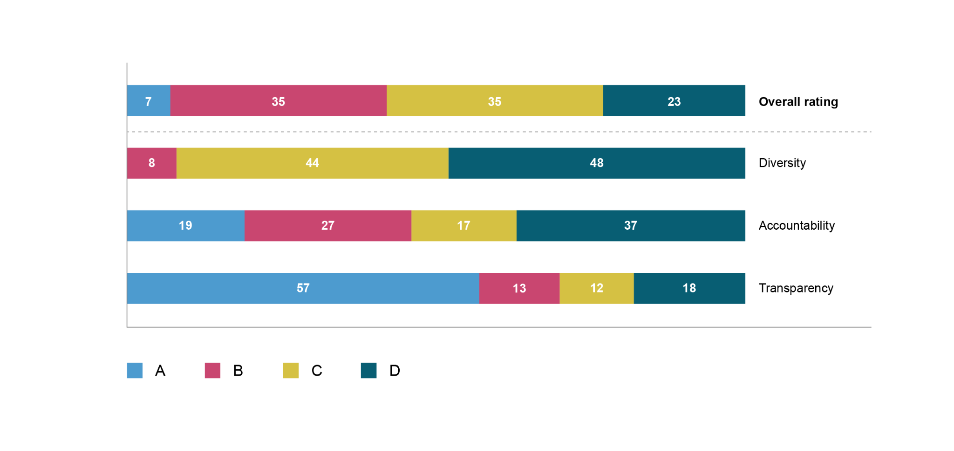
More than twice as many foundations achieved A overall in Year Two (seven) than did so in Year One (three). In both years, they were a diverse set. The foundations scoring A in Year Two are six endowed foundations (John Ellerman Foundation, Paul Hamlyn Foundation, Blagrave Trust, Esmée Fairbairn Foundation, Wellcome and the Walcot Educational Foundation) and a community foundation (Oxfordshire Community Foundation). Between them, they cover a wide range of giving budgets: Wellcome is huge, whereas Blagrave Trust is relatively small. This is similar to Year One, in which foundations with a broad range of sizes scored A overall: the three foundations scoring A in Year One were Wellcome, Blagrave Trust, and a community foundation.
As in Year One, the weakest pillar by far was diversity: again, no foundation scored A on diversity, and nearly half (48 per cent) scored the lowest mark of D. The strongest pillar was transparency, on which more than half (57 per cent) scored A.
Figure 6 shows the breakdown of pillar scores within each of the overall scores, as a percentage (for example, among foundations scoring ‘B overall’, 31 per cent scored A for accountability, 51 per cent B and 17 per cent C). The figure shows:
- Performance on transparency was relatively good – all ‘B overall’ foundations scored A or B for transparency; and 80 per cent of ‘C overall’ foundations scored A or B.
- Performance on diversity was relatively poor across the board – for example, 97 per cent of ‘B overall’ foundations scored C for diversity.
- In general, foundations with lower overall grades performed less well on individual pillars, as you might expect.
- Interestingly, 3 per cent of ‘B overall’ foundations scored B for diversity. This is an improvement on Year One, when no ‘B overall’ foundation scored higher than C for diversity. That is despite the exemptions in diversity being tightened in Year Two.
Figure 6: Percentage of foundations scoring each grade, per pillar, and grouped by their overall score
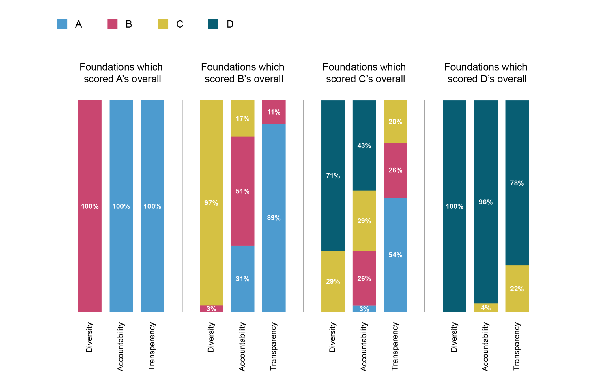

Are the criteria reasonable?
Between Year One and Year Two, all the criteria, such as having a diversity plan with numerical targets, a complaints policy, and analysing their own performance, were found in at least one foundation, demonstrating that they are all achievable. However, in Year Two, no foundation achieved the criterion of publishing diversity targets for trustees or board members based on ethnicity, disability or gender. This criterion was suggested by the Equality and Human Rights Commission for pay gap reporting. One foundation that demonstrated this in Year One was not included in Year Two. Despite this, the Blagrave Trust did have a target for trustee diversity based on a different characteristic, which was young people on its trustee board, showing that targets for trustee diversity are feasible. Figure 34 in Appendix D lists the criteria and cites examples of foundations that met each one, providing readers with guidance and examples of how to meet the criteria.

Results for individual foundations
Figure 7 sets out the grades for individual foundations, by pillar and overall.
Figure 7: Grading of foundations included in Year Two
Foundation | Diversity | Accountability |  | Transparency | Overall rating
Funders Group
Barrow Cadbury Trust | C | B |  | A | B
Blagrave Trust | B | A |  | A | A
City Bridge Trust (Bridge House Estates) | C | A |  | A | B
Esmée Fairbairn Foundation | B | A |  | A | A
Friends Provident Foundation | C | A |  | A | B
Indigo Trust | D | B |  | A | C
John Ellerman Foundation | B | A |  | A | A
John Lyon’s Charity | C | A |  | A | B
Joseph Rowntree Charitable Trust | B | B |  | A | B
Joseph Rowntree Reform Trust | C | B |  | A | B
Lankelly Chase Foundation | D | B |  | A | C
Paul Hamlyn Foundation | B | A |  | A | A
Power to Change | C | A |  | A | B
Largest foundations by giving budget
Children’s Investment Fund Foundation | C | B |  | A | B
David and Claudia Harding Foundation | D | C |  | A | C
Garfield Weston Foundation | C | A |  | A | B
Leverhulme Trust | C | C |  | A | B
Wellcome | B | A |  | A | A
Randomly selected foundations (other than community foundations)
4 Charity Foundation | D |  | D | D | D
A B Charitable Trust | D |  | B | A | C
Adrian Swire Charitable Trust | D |  | D | D | D
African Medical & Research Foundation UK Ltd | D |  | C | B | C
AKO Foundation | C |  | D | A | C
Amabrill Limited | D |  | D | D | D
Amanat Charitable Trust | D |  | D | B | C
Asda Foundation | D |  | B | A | C
Asfari Foundation | D |  | B | A | C
Banister Charitable Trust | D |  | D | D | D
Barbour Foundation | C |  | C | C | C
Baring Foundation | C |  | A | B | B
Bloom Foundation | D |  | D | C | D
British Gas Energy Trust | C |  | B | B | B
British Record Industry Trust | C |  | C | B | C
Buttle UK | C |  | B | A | B
Cadogan Charity | D |  | D | D | D
Calleva Foundation | D |  | D | C | D
Chevras Mo’oz Ladol | D |  | D | D | D
Coldstones Charitable Trust | D |  | D | D | D
Credit Suisse EMEA Foundation | D |  | D | C | C
David & Ruth Lewis Family Charitable Trust | D |  | D | D | D
Dollond Charitable Trust | D |  | C | D | D
Dorfman Foundation | D |  | D | A | C
Earl Haig Fund (Scotland) | D |  | B | B | C
Edward Gostling Foundation | C |  | C | A | B
Eranda Rothschild Foundation | D |  | D | C | C
Eureka Charitable Trust | D |  | D | D | D
Four Acre Trust | D |  | C | C | C
Gilmoor Benevolent Fund Limited | D |  | D | D | D
Global Charities | C |  | B | A | B
Grace Trust | D |  | D | A | C
Health Foundation | C |  | B | A | B
Henry Oldfield Trust | D |  | D | D | D
Henry Smith Charity | D |  | B | A | C
Hintze Family Charitable Foundation | D |  | D | C | D
Holywood Trust | C |  | C | B | C
Hugh Fraser Foundation | C |  | C | B | C
IGY Foundation | C |  | D | A | C
Innocent Foundation | D |  | B | A | C
Jack Petchey Foundation | C |  | B | A | B
Joseph Rowntree Foundation | C |  | B | A | B
Keren Association Limited | D |  | D | D | D
Kolyom Trust Limited | D |  | D | C | D
Law Family Charitable Foundation | D |  | D | A | C
Legal Education Foundation | D |  | A | A | C
Medlock Charitable Trust | C |  | C | A | B
Mercers’ Charitable Foundation | C |  | B | B | B
Mike Gooley Trailfinder Charity | D |  | D | D | D
Mission Aviation Fellowship UK Ltd | C |  | C | A | C
Mohn Westlake Foundation | C |  | D | A | C
Monday Charitable Trust | D |  | C | A | C
Nationwide Foundation | C |  | B | A | B
Newmarston Limited Group | D |  | D | D | D
One Foundation | D |  | D | A | C
Peacock Charitable Trust | D |  | D | D | D
Restore Our Planet | D |  | D | C | C
Reuben Foundation | C |  | D | A | C
R S Macdonald Charitable Trust | C |  | A | A | B
Rufford Foundation | D |  | D | B | C
S F Foundation | D |  | D | D | D
Steel Charitable Trust | C |  | C | A | B
Steve Morgan Foundation | D |  | B | B | C
Stewards Company Ltd | D |  | D | D | D
St John’s Foundation | C |  | B | B | B
Stoneygate Trust | D |  | D | C | D
Swire Charitable Trust | C |  | C | A | B
The Hunter Foundation | D |  | D | C | C
Tolkien Trust | D |  | D | B | C
Walcot Educational Foundation | B |  | A | A | A
Wolfson Foundation | C |  | B | A | B
Womankind (Worldwide) Limited | C |  | A | A | B
World Children’s Fund | C |  | C | C | C
Zurich Community Trust (UK) | C |  | B | A | B
Community foundations selected as part of the random set
Berkshire Community Foundation | C |  | B | A | B
Community Foundation for Calderdale | C |  | C | A | B
Gloucestershire Community Foundation | C |  | A | A | B
Herefordshire Community Foundation | C |  | B | A | B
Lincolnshire Community Foundation | C |  | A | A | B
Norfolk Community Foundation | C |  | A | A | B
Oxfordshire Community Foundation | B |  | A | A | A
Suffolk Community Foundation | C |  | B | A | B

Opt-in results
As mentioned, this year foundations were offered the option to opt-in to be rated. This involved a small fee and 'opt-in' foundations were researched and assessed in exactly the same way as all the other included foundations.
One foundation did opt-in: the KPMG Foundation. It had been included in Year One, when it achieved C on diversity, C on accountability, and A on transparency, leading to B overall. This year, KPMG Foundation's numerical scores had improved on all three pillars. Its grade in Year Two was C on diversity, and it moved up to B on accountability and again achieved A on transparency, leading again to B overall.
Interestingly, KPMG Foundation reported the diversity of its trustees on gender, ethnicity and socio-economic background. Unusually, this is not buried in some report but rather appears as a very clear graph on its website. KPMG Foundation was the sole foundation researched this year that reported on the socio-economic background of trustees. (To be clear, reporting on this was not a criterion this year. Rather, we gathered information about whether and what foundations report on this.) We noticed that KPMG LLP (the company) produced a report in December 2022 about the diversity of its workforce by social class, and in particular the differential speed at which people from different social classes move up the career ladder.

Foundations reporting about lived experience and social class
In Year Two the researchers collected data on whether or not foundations reported information about the lived experience and/or social class of their staff and trustees, to find out whether and how foundations report on these issues and what definitions they use. This was done with a view to possibly adding relevant criteria in future: FPR in Year Two did not include criteria about these issues. Specifically, information was collected on whether or not either category was mentioned in staff and trustee biographies, in the staff and trustee diversity reporting and/or as targets for staff and trustees in any diversity plans.
Lived experience
Staff: Seven foundations provided information about lived experience in staff biographies (Blagrave Trust, Joseph Rowntree Charitable Trust, Wellcome, African Medical & Research Foundation, Health Foundation, Jack Petchey Foundation and Womankind Ltd). No foundation’s diversity report included information on the lived experience of its staff.
Trustees: Four provided information on lived experience in trustee biographies (Blagrave Trust, Paul Hamlyn Foundation, Health Foundation and Jack Petchey Foundation).
One foundation, Blagrave Trust, reported in its diversity report on the lived experience of its board members.
Social class
Staff: No foundation provided any information about social class in staff biographies.
One foundation, Garfield Weston, reported on the social class of its staff members (as ‘first generation university graduates’) in its diversity report.
Trustees: None in the main sample of 100 foundations reported on the social class of its board, nor included it in trustee biographies. KPMG Foundation, which opted-in and so is outside the main sample of 100 foundations, did report on this: specifically on the proportion of trustees ‘from working-class backgrounds’.
No foundation’s diversity plans reported specific targets for either the lived experience or social class of staff and for trustees. However three foundations did mention within their diversity plans an aim to hire staff with ‘lived experience’: Paul Hamlyn Foundation, Power to Change and Oxfordshire Community Foundation.

05. Analysis of results

High-level observations

Overall grades and relationship with pillar scores
Figure 8 compares the overall ratings in Year One and Year Two.
Note that this covers all the foundations included in each year, so some foundations appear in both years, and others in one year only. The effect of the sample changes year-on-year, and changes in performance despite that, are assessed later in this section.
Figure 8: Comparison of overall grades in Year One and Year Two
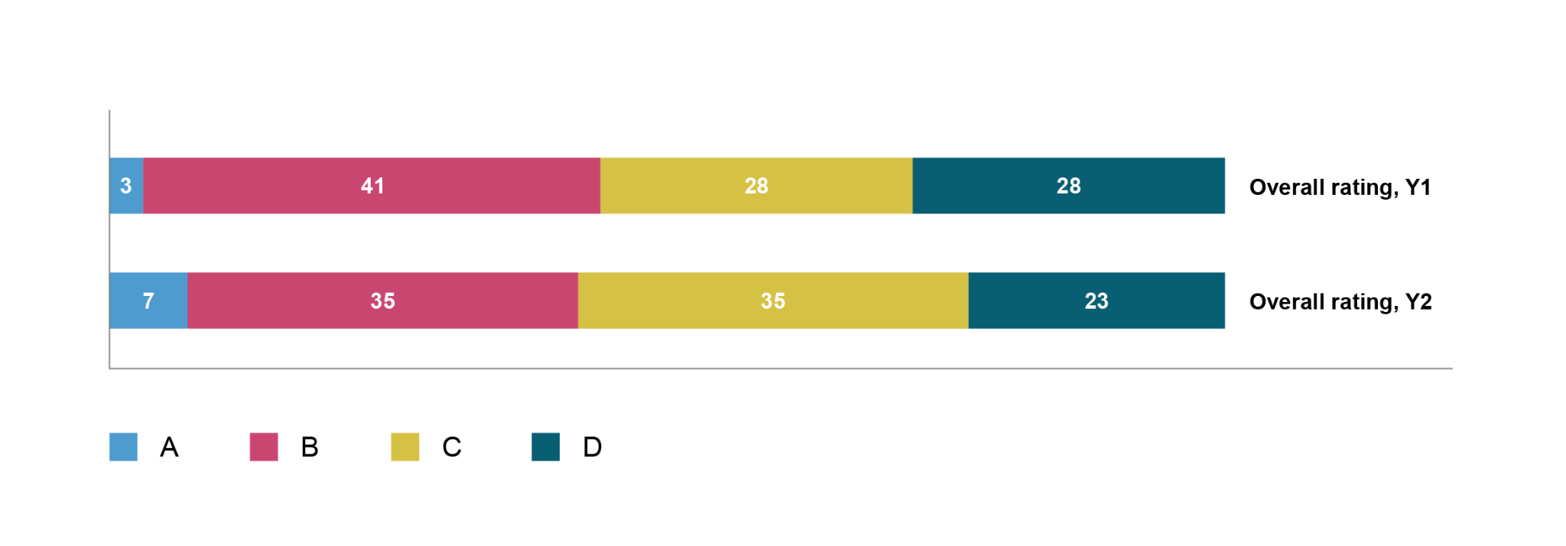
The performance between the two years is broadly similar. There are some slight changes – encouragingly, fewer foundations scored D and more scored A. However, there was an increase in the number scoring C and a decrease in B scores. Page 37-40 sets out a more detailed analysis.
Figure 9 shows the scores for each included foundation in each pillar. The bars are coloured according to the foundation’s overall score, rather than its rating on that pillar.

Figure 9: Scores in each pillar in Year Two, with overall rating indicated by colour
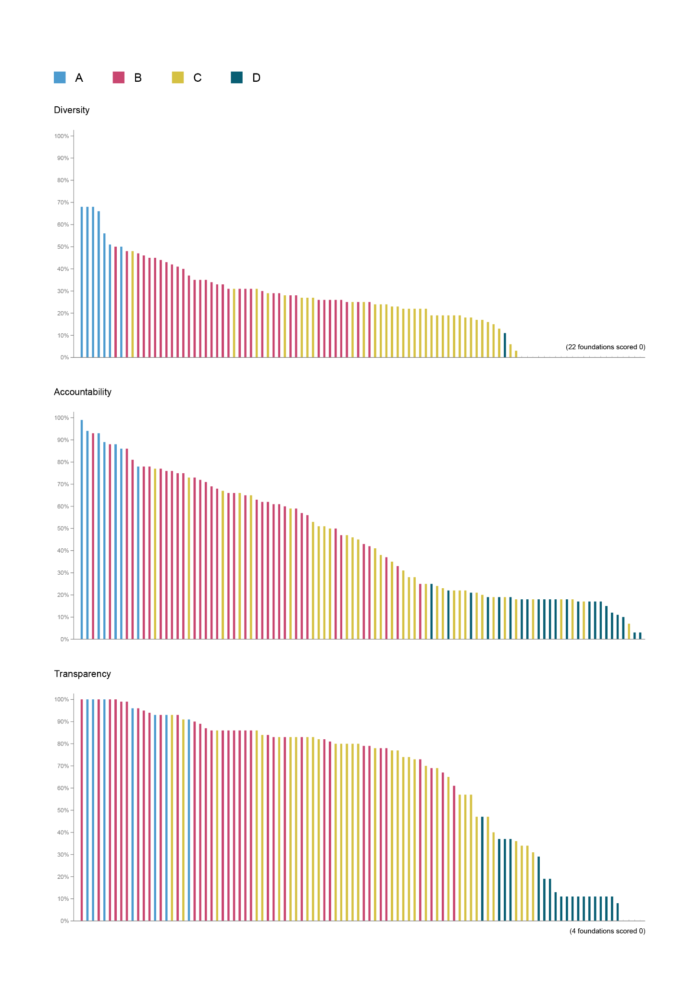
In Figure 9, the distribution of scores in each pillar is quite continuous, i.e. there are no ‘clumps’ of foundations or large jumps in the scores, there are only some very small discontinuities.
However, some ‘B overall’ foundations are out-performed on that pillar by ‘C overall’ foundations. Similarly, on all three pillars, some ‘C overall’ foundations are out-performed on that pillar by at least one foundation that scores D overall. The graphs all have the same y-axis scale: notice how the scores on diversity are lower than those on the other pillars.

Diversity
Figure 10 shows the grades achieved in diversity in the two years.
Figure 10: Diversity grades in Year One and Year Two
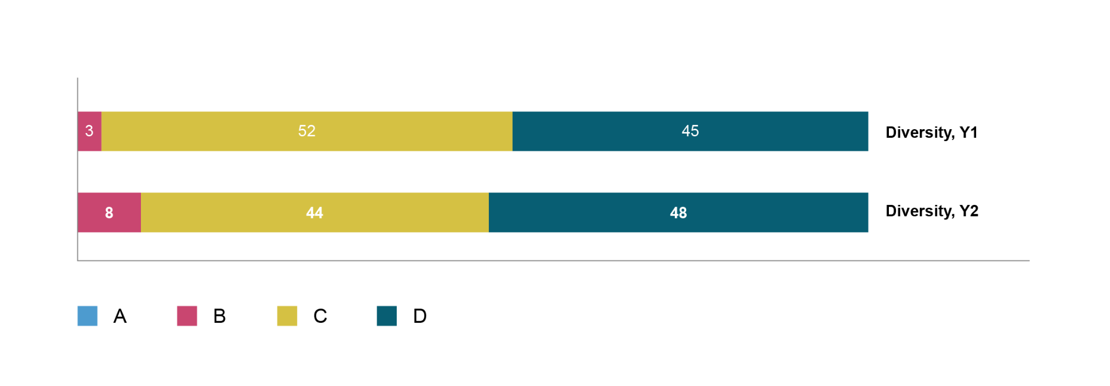
No foundation scored A in either year. A few more scored B in Year Two, but a few more scored D. There is a more detailed commentary on page 48-49 about performance on diversity.
As mentioned, one criterion was changed, and the balance of scoring on another was adjusted. Both relate to diversity. They are: the exemption for reporting staff diversity breakdowns was reduced from ten or fewer staff in Year One, to five or fewer staff in Year Two; and the scoring for social media communication was simplified. The first change affected some foundations’ scores: it caused four foundations to drop by one grade in their diversity score, and five foundations to drop by one grade in their overall assessment (those four, plus one other whose numerical average score fell because of that change, but this foundation still received the same grade as in Year One). The second change also caused a foundation to drop by one grade in its diversity score, which fed through into a fall in its overall assessment.
Encouragingly, the number of foundations reporting the diversity of trustees and staff increased. One foundation reported trustee diversity in Year One, but five did so in Year Two. On staff, whereas in Year One, only one foundation reported staff diversity, six did so in Year Two.

Accountability
Figure 11 shows the grades achieved in accountability in the two years.
Figure 11: Accountability grades in Year One and Year Two
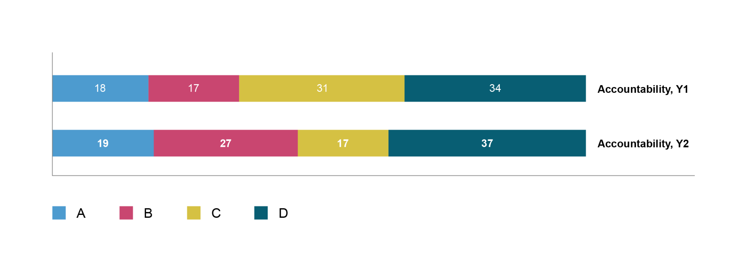
The clearest change is that in Year Two many more foundations scored B for accountability, and many fewer scored C.

Transparency
Figure 12 shows the grades in transparency in the two years.
Figure 12: Transparency grades in Year One and Year Two
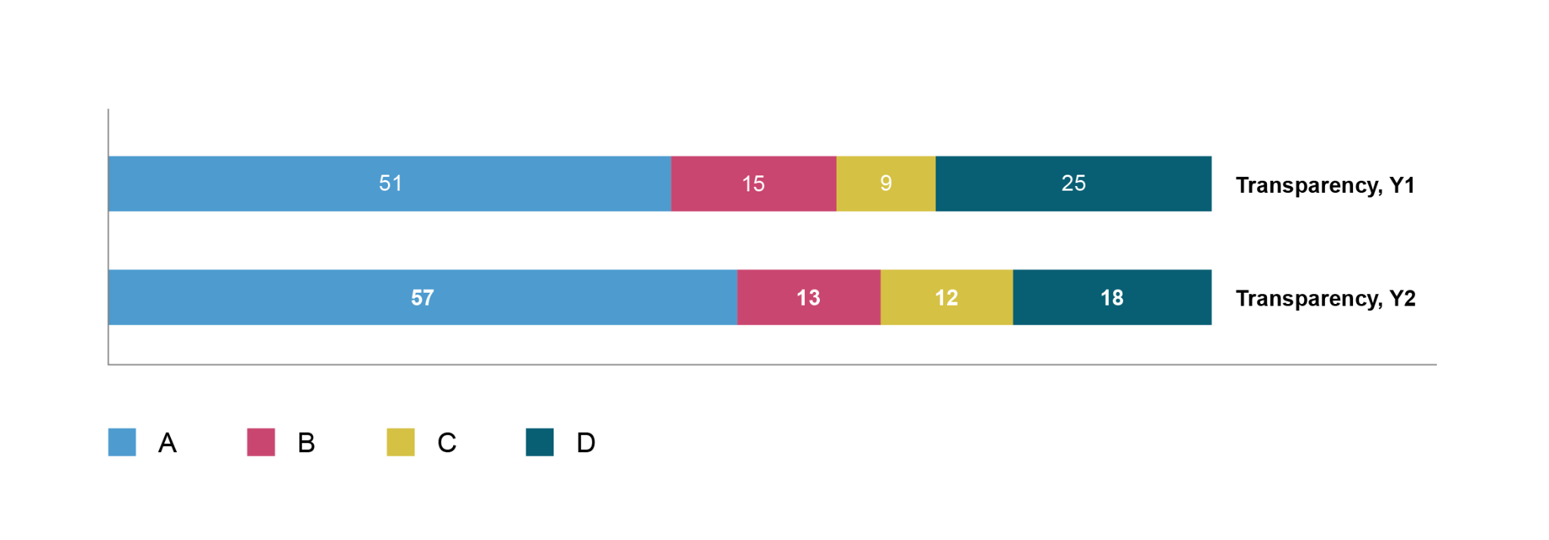
Overall, the sample in Year Two scored better on transparency than the sample in Year One. There were more As and fewer Ds, and a similar number of those in the middle (either B or C). As mentioned, this does not necessarily mean that performance has improved: perhaps these changes are just a function of the new sample (discussed below).

Changes in foundation practice over time
This section considers whether there has been a general improvement or deterioration in foundations’ practice between Year One and Year Two. It compare the rating in the two years and shows the percentage change. The results cannot be compared directly because the foundations assessed in the two years were not identical. That is explored below.
Figure 13 compares the average overall scores and pillar scores for Year One foundations vs the Year Two foundations.
Figure 13: Comparing overall average and pillar scores in Year One and Year Two
 | Overall average score | Diversity pillar score | Accountability pillar score | Transparency pillar score
Year One | 0.42 | 0.24 | 0.43 | 0.60
Year Two | 0.45 | 0.24 | 0.45 | 0.65
Percentage change | +7.1% | No change | +4.4% | +8.3%
The figures above suggest that there might have been a small change in the performance in Year One compared with Year Two. But this could be because the set of foundations analysed varied between the two years, rather than because of any significant change.
One way to examine this is to examine the set of foundations that were included in both years (the ‘included both years set’) (Figure 14 overleaf).
The foundations that were included in both Year One and Year Two showed an improvement in their scores, both overall and in each of the three pillars. The increase in scores was comparable across all three pillars and the overall score. The diversity score showed a larger percentage increase, as it started from a lower baseline. However, it's worth noting that the diversity score is not a direct comparison, as the change in the threshold for staff diversity plans this year means that the figures may underestimate the performance in Year Two compared to Year One.

Figure 14: Comparing overall average and pillar scores in Year One and Year Two for foundations included in both years
 | Overall average score | Diversity pillar score | Accountability pillar score | Transparency pillar score
Year One | 0.52 | 0.30 | 0.53 | 0.72
Year Two | 0.56 | 0.33 | 0.58 | 0.76
Percentage change | +8% | +10% | +9% | +6%
Did all the ‘included both years ’ foundations show improvement? Figure 15 shows changes in their performance over the two years. The results are mixed, but more foundations improved than deteriorated. This shows that there is net improvement that is not a result of the random selection process.
Figure 15: Number of ‘included both years’ foundations whose scores improved or got worse
Number of foundations… | …improving between Year One and Year Two | …staying the same between Year One and Year Two | … deteriorating between Year One and Year Two
Overall score | 18 | 1 | 9
Diversity pillar score | 16 | 2 | 10
Accountability pillar score | 20 | 2 | 6
Transparency pillar score | 13 | 9 | 6
Figure 16 compares the scores of foundations that have only been assessed once (either in Year One or in Year Two). Seventy foundations that were assessed in Year One were not included in Year Two, and 68 foundations in Year Two had not been assessed in Year One.
Figure 16: Comparing average overall and pillar scores for foundations that were assessed once, either in Year One or in Year Two
 | Overall average score | Diversity pillar score | Accountability pillar score | Transparency pillar score
Year One | 0.38 | 0.21 | 0.38 | 0.54
Year Two | 0.39 | 0.20 | 0.39 | 0.59
Change | +2.6% | –5% | +2.6% | +8.5%
This suggests that there might have been some improvement in some areas, especially in transparency. But the evidence is quite weak. As mentioned above, the diversity Year Two pillar understates performance on a like-for-like basis.
To further explore this, only the foundations within this group that had websites were evaluated, as websites generally provide more comprehensive information than annual reports alone. For this particular set, their scores for transparency, accountability and overall were almost identical between the two years. However, the diversity score was slightly lower, which could be attributed to the change in exemption for the staff diversity criterion or the revised scoring on social media. The overall diversity score was also marginally lower in Year Two, which could also reflect the exemption change. This implies that progress (if any) outside of the foundations evaluated in both the ‘always included’ and ‘included twice' sets could potentially be among those that do not have websites. Nevertheless, the limited information available on foundations without websites only allows for suggestive findings at best.

Results for particular groups of foundations

The five largest foundations by giving budget
Figure 17 shows how the five largest foundations (by giving budget) performed. It shows the distribution of overall ratings for all the included foundations, and the ratings of the five largest foundations.
Despite two of the five changing between the two years, the distribution of overall ratings is constant: one A overall (Wellcome), three Bs, and one C. In other words, it is possible to be very large and yet score poorly. FPR scores are not just a function of giving budget.

Figure 17: Overall grades of the five largest foundations by giving budget in Year One and Year Two
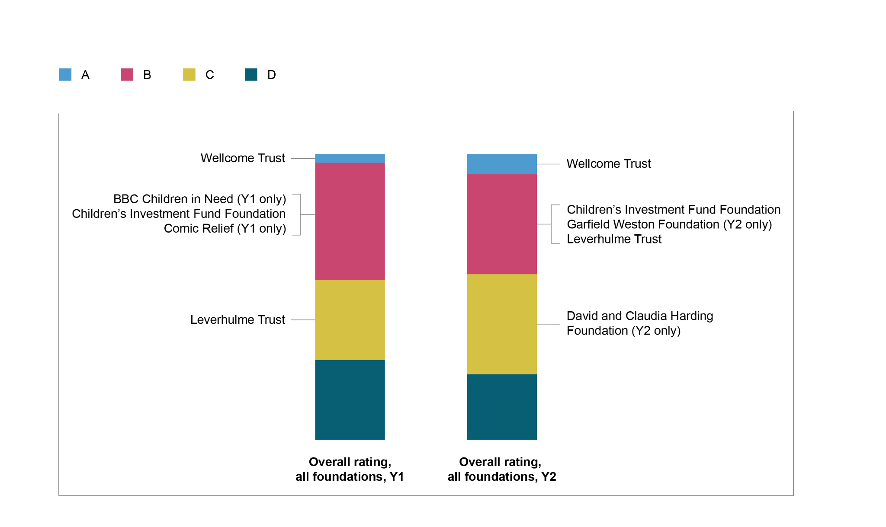

Foundations that fund the FPR
Figure 18 shows how the Funders Group of foundations performed. It shows the distribution of overall rating for all the included foundations, and particularly the overall ratings of the Funders Group.
Overall, performance of the Funders Group improved: in Year One only one scored A overall, but in Year Two four did so. Individually, most of the Funders Group improved their performance. The exception is Lankelly Chase, which dropped from B to C.

Figure 18: Overall grades of Funders Group foundations in Year One and Year Two
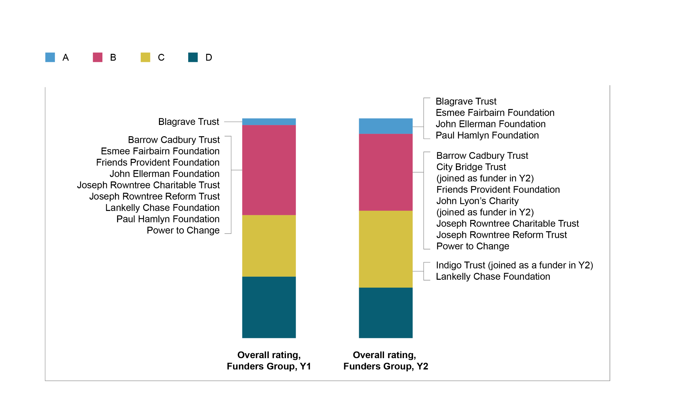
Figure 19 is a detailed analysis of the changes in scores and grades for the Funders Group between the two years. It includes the foundations that were part of the Funders Group in both years, and not those that joined in Year Two (Indigo Trust, City Bridge Trust and John Lyon’s Charity).
Figure 19: Comparing the performance of the Funders Group on numerical scores and ratings grades in Year One and Year Two
 | Overall score | Div score | Acc score | Trans score | Overall grade | Div  grade | Acc grade | Trans grade
Friends Provident Foundation | Improved | Improved | Improved | Improved | Same | Same | Improved | Same
John Ellerman Foundation | Improved | Improved | Improved | Improved | Improved | Improved | Improved | Same
Barrow Cadbury Trust | Improved | Improved | Improved | Improved | Same | Same | Improved | Same
Paul Hamlyn Foundation | Improved | Improved | No change | No change | Improved | Improved | Same | Same
Lankelly Chase Foundation | Got worse | Got worse | Got worse | No change | Got worse | Got worse | Got worse | Same
Blagrave Trust | Improved | Improved | Improved | Improved | Same | Same | Same | Same
Esmée Fairbairn Foundation | Improved | Improved | Improved | Improved | Improved | Improved | Same | Same
Joseph Rowntree Charitable Trust | Improved | Improved | No change | No change | Same | Improved | Same | Same
Joseph Rowntree Reform Trust | Improved | Improved | Improved | No change | Same | Same | Improved | Same
Power to Change | Improved | No change | Improved | Improved | Same | Same | Same | Same
In Year One, all the Funders Group foundations scored slightly better than average: they all scored either A or B overall. The Blagrave Trust was one of only three foundations that scored A overall, scoring better than average on all three pillars.
Comparing the Funders Group in Year One and Year Two:
- Diversity: In Year One, all were rated B or C. The average diversity rating for all included foundations was on the D/C borderline. Year Two was similar, although Lankelly Chase moved to D.
- Accountability: In Year One most were rated either A or B, with the exception of Barrow Cadbury Trust and Joseph Rowntree Reform Trust, who rated were rated C. By contrast, the average across all foundations for accountability was C. In Year Two, the pattern was similar.
- Transparency: In Year One all the Funders Group rated A, whereas the average across all included foundations was B (i.e. the numerical mean score across all 100 foundations was in the range that scores B).

Community foundations
Figure 20 highlights how the included community foundations performed. It shows the distribution of overall ratings for all included foundations, and shows the ratings of the included community foundations.
Figure 20: Overall grades of community foundations in Year One and Year Two
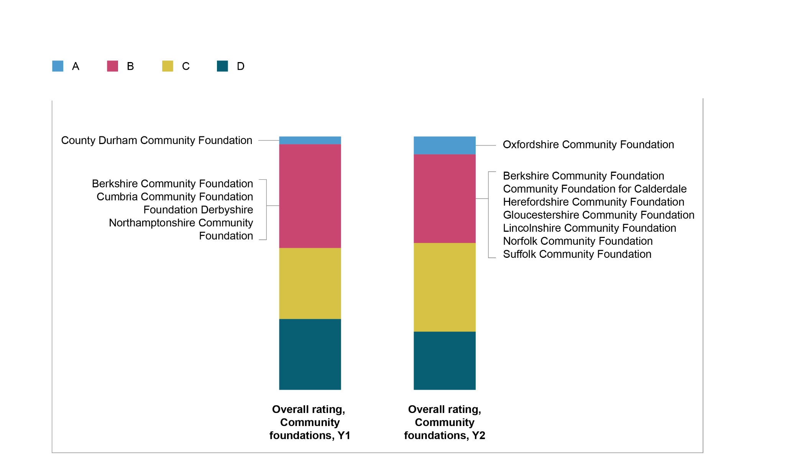
Note that, due to the random selection of foundations, most of the community foundations included in Year One were not included in Year Two. Only the Berkshire Community Foundation was included in both years.
Community foundations scored better than average, with all scoring A or B overall, in both years.
On diversity, all the included community foundations scored B or C in both years. By contrast, the average diversity score for all included foundations was on the D/C borderline.
On accountability, in Year One all the included community foundations scored A or B. In Year Two all scored A or B, with the exception of one C. By contrast, the average across all foundations for accountability was C in both years.
On transparency, all the included community foundations scored A in both years, whereas the average across all included foundations was B.

Performance by criteria

Criteria on which foundations scored highest overall
Figure 21 lists the ten questions on which the included foundations collectively performed best, taking into account that some foundations were exempt from some questions. None of the best-scoring criteria is in the diversity pillar: that also happened in Year One. This highlights how foundations in the sample tend to do well on transparency criteria, and that high-scoring questions are relatively consistent between Year One and Year Two.
Figure 21: The ten questions on which the foundations collectively scored highest
Question | Pillar | % of points scored by non-exempt foundation | In the 10 highest scoring questions in Year One?
26. Does the foundation give any information on who or what it funded? | T | 91% | Yes
73. Does the foundation have an investment policy and coverage of investment policy? | A | 90% & 78% | Yes
25. For approximately what percentage of the foundation’s funding programmes is information given on who made the funding decisions (either a panel or a person)? | A | 87% | No
36. Does the foundation publish who its staff are on its website? | A | 78% | Yes
02. Does the foundation have a website? | T | 78% | Yes
08. Does the foundation publish on its website any information about its funding priorities? | T | 77% | Yes
58. Is there contact information provided on the foundation’s website? | T | 74% | Yes
10. Does the foundation state how to apply for funding? | T | 70% | Yes
28. Level of information provided about the awarded grants. | T | 70% | Yes
15. Does the foundation publish any eligibility criteria for what it funds? | T | 67% | No

Criteria on which foundations scored lowest overall
Figure 22 shows the ten criteria on which the foundations collectively performed least well, again taking account of the fact that some foundations were exempt from some criteria. Questions on which foundations scored worst were the same in Year One and Year Two. Again, this list is almost entirely about diversity.
Figure 22: The ten questions on which the foundations collectively scored lowest
Question | Pillar | % of points scored by non-exempt foundation | In the 10 lowest scoring questions in Year One?
54. Inclusion of specific numerical targets to improve diversity of trustees or board members. | D | 1.7% | Yes
55. Use of ethnicity, disability and gender targets that are in any diversity plan for trustees. | D | 0% | Yes
47. Whether any staff diversity plan includes specific, numerical targets. | D | 4.7% | Yes
48. Coverage of targets in any diversity plan for staff. | D | 3.1% | Yes
64. More than one way given for contacting the foundation concerning malpractice. | D | 4.0% | Yes
31. If the foundation funds recipients in Wales, is a Welsh language format provided? | D | 5.6% | Yes
60. Ways to contact the foundation for people who have disabilities? | D | 6.0% | Yes
51. Does the foundation publish a breakdown of the diversity of its trustees/board members? | D | 8.5% | Yes
63. Is there a mechanism to report malpractice concerns (whistleblowing)? | A | 11.0% | Yes
44. Does the foundation publish a breakdown of the diversity of its staff? | D | 14.0% | Yes

Criteria showing most change between Year One and Year Two
Questions with the largest increase (showing improvement) or decrease (deterioration) in scores are listed in Figures 23 and 24.
Figure 23: Questions showing the most improvement between Year One and Year Two
Question | Pillar | Absolute change in score
32. Are funding success rates provided, or  33. Is there a reason given why not? | T | + 20%
11. Is it possible to submit funding proposals in a range of different formats? | D | + 16%
71. Does the foundation cite any evidence that it has consulted the communities it seeks to support in determining its funding priorities? | A | + 16%
50. Has the foundation made a public commitment to be a Living Wage employer? ‘N/A’ if there are no staff. | D | + 14%
23. Does the foundation cite any criteria on which its funding decisions are made? | A | + 10%
Figure 24: Questions showing the most deterioration between Year One and Year Two
Question | Pillar | Absolute change in score
57. Does the foundation publish its recruitment policy for board members? | D | – 11%
4. Can you navigate the foundation’s website using only the keyboard (without a mouse)? | D | – 8%
37. Does the foundation provide a bio for its senior staff? | A | – 8%
73. Does the foundation have an investment policy? | A | – 7%
46. Does the foundation have a plan to improve the diversity of its staff? | D | – 7%
At first sight, it looks like there have been some large changes. But they could result from the ‘always included foundations’ making changes, or the randomness in the set of foundations included, or from the fact that FPR measures many items and one would expect some large changes.

How performance has changed from Year One to Year Two
Most of the Funders Group have improved between Year One and Year Two. But it would be interesting to know whether there has been a broader change in the sector. To examine this, the research team examined the statistical likelihood of such a change occurring purely by chance among the randomly-selected foundations (i.e. the relevant p-value). This analysis suggested that only the changes in publishing success rates and in investment policy could be unusual – and then only if these were the only questions asked. But the FPR contains many questions. Given the number of questions that it asks, it is quite likely that, just by chance, there would be some questions on which scores change this much.
No conclusions can be drawn about the broader sector from these figures. This does not mean that there is no change in the sector, of course: rather, that this study does not provide good evidence of it yet.
The rate of change may vary between different types of change. Some changes in foundations can be made by relatively junior staff members. Perhaps the areas where improvement has been made are like this. Other changes may require board engagement, governance cycles and possibly non-trivial expenditure (for instance, if a website needs to be revamped). Arguably, some of those where improvement has been weak are like this.

Update on themes identified in Year One

Poor performance on the diversity pillar
One of the main findings from Year One was that practice on diversity was weaker than on the other pillars. No foundation scored A on diversity, whereas many were rated A on the other two pillars: 51 for transparency and 18 for accountability.
That pattern was repeated in Year Two. No foundation scored A on diversity; practice was much worse than the other pillars: 57 foundations scored A for transparency and 19 for accountability.
Though many foundations had diversity statements, stating that they have a commitment to equality and diversity within their organisations and in their funding, very few had a diversity plan with targets. Across the foundations in Year Two, 14 had diversity plans for their staff (as in Year One), yet only two of these contained any specific targets for gender, ethnicity or disability. Fifteen foundations had a diversity plan for their trustees (up from 10 in Year One), but none had a diversity plan with specific diversity targets for its trustees for gender, ethnicity or disability.
Figure 25 gives the average numerical scores across all 100 foundations on each pillar by year. It shows the differences in average performance between the pillars, and how those have been maintained in Year Two.
Figure 25: Average grades on the pillars
 | Diversity | Accountability | Transparency
Average grade  Year One | D (near the border  for C) | C | B
Average grade  Year Two | D (near the border  for C) | C | B
The number of foundations scoring zero in each pillar is shown in Figure 26. The number of foundations scoring zero on diversity increased this year.
Figure 26: Number of foundations scoring zero in each pillar
 | Diversity | Accountability | Transparency
Scored zero  Year One | 16 | 0 | 4
Scored zero  Year Two | 22 | 0 | 4
It is possible that the criteria in some pillars are more difficult to meet than those in other pillars. If so, that would account (in part or in full) for differences in the pillar ratings. In some cases, there seems no way of knowing this in absolute terms – though each item sought by the criteria is possible because each item was found in at least one foundation.

Board diversity reporting
Though many foundations do not report board diversity, some do, which shows that it is feasible. The Walcot Educational Foundation, which was selected randomly, publishes a two-page report about it, accessible on the website from the main menu. It cites diversity by: ethnicity, gender, age, religion, sexual orientation and disability.
Most foundations that do report their board diversity do so through statements in the annual report. The sole foundation that the research team has identified that has graphs of its diversity on its website is the KPMG Foundation – which opted in and so is outside our sample of 100 foundations.

Does size matter?
In Year One, the FPR data showed that financial size did not correlate with foundations’ ratings, but size by number of staff and trustees did. There was a similar pattern in Year Two – a positive and reasonably strong correlation between the number of trustees and performance on all three pillars. More information is in Appendix E.
Note that the ‘random selection’ of foundations in the FPR is drawn from the 300 largest foundations in the UK – plus community foundations and foundations that fund FPR. Small foundations are outside its reach.

Scores by giving budget
As in Year One, the research team assessed the overall ratings for foundations divided into quintiles – first by giving budget and then by net assets.
In Year Two, as in Year One, there was no relationship between the foundations’ giving budget and their overall rating, or their net assets and their overall rating – each quintile had a mix of overall scores. In other words, some foundations with pretty large giving budgets scored badly, and some foundations with relatively small giving budgets scored well.
The Year Two results are set out in Figure 27.
Some foundations rated A overall had relatively small giving budgets and net assets. Overall ratings of B and C are distributed throughout the range of giving budgets; and some foundations scoring D overall have remarkably high giving budgets and assets.

Figure 27: Overall scores of foundations, ordered by financial size (Year Two)
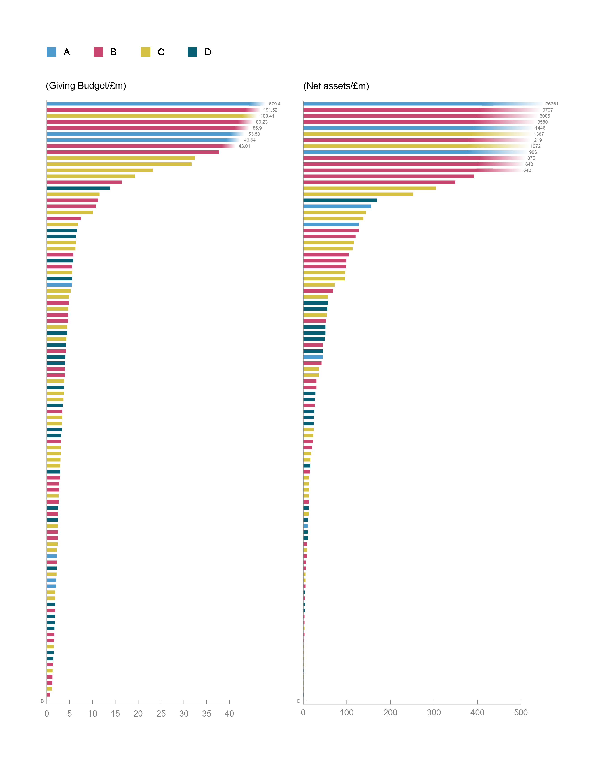

Results by size of team – staff and trustees
In Year One there was some correlation between the number of staff and the overall grade: foundations with no staff tended to score lower than foundations with some staff; and foundations with few staff tended to score lower than foundations with more staff.
Much the same was found in Year Two: the lowest grade of D was almost wholly confined to foundations with 10 or fewer staff (Figure 28).
Figure 28: Breakdown of overall grade by number of staff in each foundation (Year Two)
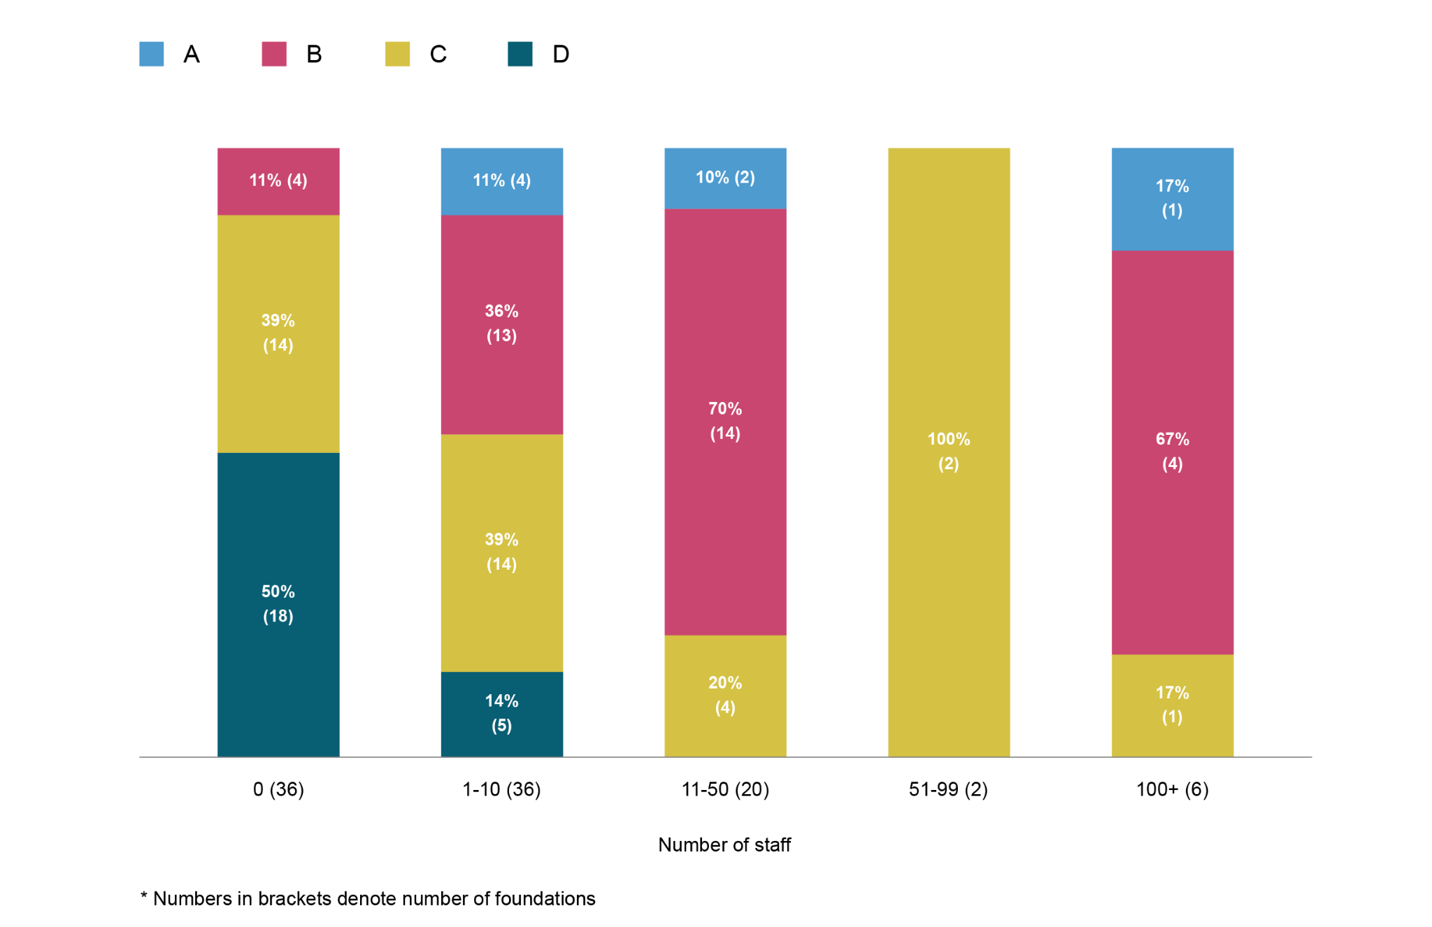
In Year One, the number of trustees showed a similar pattern to staff size. Foundations with five or fewer trustees tended to perform worse. The same was the case in Year Two: as Figure 29 shows, an overall grade of D was more common amongst foundations with few trustees, and A was more common amongst foundations with more trustees.

Figure 29: Breakdown of overall scores by number of trustees at each foundation

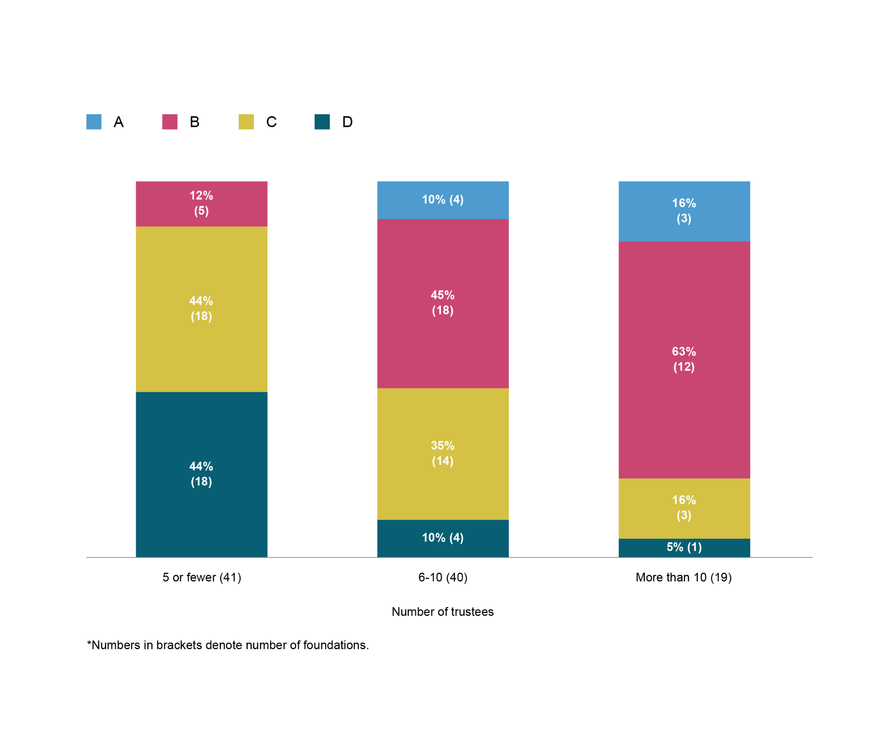Are low scores confined to foundations with few staff?
In Year One, 28 foundations scored D overall. Indeed, 22 of these scored D on all three pillars. This is a large proportion of the 100 foundations assessed. Foundations scoring D overall spanned the size range (in terms of giving budget), with some in each quintile. None of the foundations that scored D on all three pillars had a website, and about 40 per cent of them did not provide an email address (so the data about them had to be sent to them by post).
The findings were similar in Year Two. Twenty-three foundations scored D overall, of which 17 scored D on all three pillars. Again, they spanned the size range (in terms of giving budget), with some in each quintile.

Why do foundations with few personnel score badly?
It is not clear, from the evidence gathered by the FPR, why this is the case. As a reminder, foundations with few staff and/or few trustees are exempt from many criteria (e.g. publishing pay gap data) so it is unlikely that FPR penalises foundations for deciding to have few staff and/or few trustees.
It may be because disclosing the information that the FPR requires takes work, and having too few personnel means that foundations lack the labour to do it. Nevertheless, the FPR criteria are similar to organisations’ benchmarks and were subjected to two consultations with the sector, suggesting that this is information that the sector wants to know about. Although funds spent on staff are not available for grants, having too few staff may be a false economy, in that having more staff might enable some foundations to improve their performance and impact.

‘Do as I say and not as I do’
In Year One, the data showed that foundations sometimes required something from their grantees that they did not seem to do themselves. Examples included requiring grantees to have complaints procedures or whistle-blower procedures, but not having them themselves (that could be found), requiring grantees to commit to paying the Living Wage but not themselves having a public commitment to doing so (that could be found), or requiring grantees to consult with the communities they serve (e.g. in determining their priorities) but not reporting that they do so themselves (that could be found). This was not particularly noted in Year Two by the researchers, so is not examined further here.

New themes in Year Two

Foundation websites
In general, foundations with websites were good at publishing their funding priorities, eligibility information and information about who and what they have funded. Having a website is essential to performing well, both in the pillars and overall: no foundation without a website scored above D overall.
Seven out of 23 (30 per cent) that scored D overall did not provide an email address (so the data about them had to be sent by post), and 6 out of the 17 (35 per cent) that scored all Ds did not provide an email address.
Many foundation websites could be improved:
- 22 foundations in the Year Two sample had no website at all.
- One foundation required people to register in order to get information from its website. Registration required a postal address. Once registered, the only information on the website was a ‘donation page’.
- Many foundations’ websites were hard to navigate, and many had no working search function.
- Some websites were very busy, impeding finding information quickly and easily.
- Some websites featured very little information. Two had just a single webpage, and another only contained broken links.
- Not all the websites were easy to find. Surprisingly, the researchers missed the website of one of the five largest foundations (by giving budget) when they searched for it using Google, and it was only found by using a different search engine.
Many websites did not appear to have been designed or maintained with the external user in mind. This matters because, in the words of Tom Steinberg, founder of mySociety.org and co-founder of Modern Grantmaking:
Your website IS your organisation (as far as your customers are concerned)...
Increasingly, when a modern citizen looks at a government website, they’re literally seeing the state. And if what they see is ugly, confusing or down-right-broken, increasingly that’s how they’re going to see the state as a whole.
Feedback from the Funders Group suggests that it is difficult for foundations – few of which have dedicated IT expertise – to find sound advice and the technical skills to deliver good quality amongst the plethora of those that offer it. The findings suggest it would be a useful area for support from infrastructure bodies.

It’s very difficult to contact some foundations
In both Year One and Year Two, each included foundation was sent the data about it, for it to check. The contact details that they provide were used, and for a surprisingly large number that was not email but a postal address – so the information was sent by post. In many cases, the email address is generic – such as info@ or enquiries@ – and sometimes it is that of a lawyer.
Quite often, the foundations that were emailed did not reply, and upon enquiry researchers were told that the emails had not been received. Presumably they go to a ‘spam’ folder that is not checked. This means that, for many foundations, the contact details that a prospective applicant might use go to some place which is not checked.
All charitable foundations operate in the public interest and are subsidised by the tax-payer. It seems reasonable to expect that outsiders should be able to contact them.

Evidence and analysis of foundations’ own effectiveness
Foundations vary considerably in the extent to which they publish analyses of their own effectiveness, or show evidence of having consulted with the communities they intend to serve.
Great foundation practice includes conducting surveys of grantees (or commissioning a research house), publishing the results in full and identifying areas where the foundation intends to improve as a result. One foundation that has done this is the John Ellerman Foundation: it has published results and analyses of a survey of its grantees and unsuccessful applicants.
There is a really nice example from The Buttle Trust. It has used feedback from recipients to identify practical ways that it can improve:
The information we receive through our surveying allows us to get feedback on where we can improve. From this we are aware that a very small number of families report that they have not received their grant in full. This is typically because items are not being delivered or grants are not spent in their entirety. Some of this is being compounded by supply chain issues, and the ongoing impact of the Covid-19 pandemic. The feedback allows us to identify such issues and look for ways to mitigate or fix them, so that our impact continues to remain as high as it can for all who need a grant.
The Gloucestershire Community Foundation (GCF) provides an example of citing feedback without publishing it in full. GCF surveyed 100 Gloucestershire organizations, but it is unclear how the organizations were chosen. Despite this, GCF discusses the actions they are taking as a result of the feedback. The survey indicated a need for mentoring for charity leaders, marketing support, and resilience and finance planning. GCF has responded by launching a mentoring programme for charity leaders in Gloucestershire.
In terms of consulting with communities to determine their funding needs and approaches, there were various examples. One is the City Bridge Trust. Unusually, in formulating its current strategy (which runs 2018–23), it consulted with ‘a range of internal and external audiences’, including via in-person events.
A few foundations stated that they have analysed their work but do not publish it. That is a shame, because it precludes others from learning from their analysis, methods and findings. For instance, one said simply that a staff member ‘has carried out a wide review of our activities, including a survey of grantees, [and] analysis of our grant-making’.
Some foundations had evidently consulted with stakeholders in (at least) some of their programmes. For instance, John Ellerman Foundation funds – among other things – work with museums, and published notes from a conference with curators about issues that they faced and how funding helps them and could help more.
The Children’s Investment Fund Foundation publishes a case study of a programme that did not work.
Very few foundations published the kind of analysis of their effectiveness that is required of many operational charities: quantitative, experimental and covering all of the organisation’s work. One that did was Wellcome. It published a detailed quantitative analysis of the effectiveness of its grants, using its Success Framework. Laudably, this included comparators, such as the proportion of outputs funded by Wellcome that are accessible compared to those funded by other funders; and the success/influence of research outputs measured by bibliometric indicators.
The FPR has, to date, accepted unpublished documents and surveys as evidence that foundations have assessed their practice, if such work is mentioned on a foundation’s website. However, the researchers may in future require details of such studies to be published, in order for a foundation to score for those questions.

Examples of great practice
As was the case in Year One, the research encountered some practices that seem particularly strong. Some are cited in Figure 30 (overleaf) to inspire other foundations and to show what is possible.
The research team has not produced a list of bad practice. This is largely because most ‘bad practice’ is simply that things are absent; for instance, a foundation does not publish pay gap data or its funding priorities, or its website cannot be read without a mouse.

Figure 30: Examples of particularly good practice
Practice | Foundation
Has both trustees and staff who had been recipients of their Achievement Awards and Internship Programme | Jack Petchey Foundation
A Disability Confident employer, committed to the recruitment, progression and retention of individuals with disabilities | Joseph Rowntree Foundation
Has a network of local advisors to support applicants through the process | Norfolk Community Foundation
Straightforward and clear presentation of funding information | Nationwide Foundation
Homelessness deep-dive series report is a good example of understanding the problem(s) which the foundation is trying to address, and consulting communities | Mercers’ Charitable Foundation
Published, systematic grantee feedback | John Ellerman Foundation
Nicely presented, comprehensive website without information overload | Gloucestershire Community Foundation
Annual report provides breakdown of trustee diversity, which is rare among foundations. Rare foundation to publish its recruitment policy for staff and trustees | John Ellerman Foundation
Specific diversity equality and inclusion committee working with other committees within the Trust to ensure accountability and transparency | British Record Industry Trust
Very good website from the point of view of the grantee. Easy to find things, clearly set out | Paul Hamlyn Foundation

06. Reactions from foundations and FPR responses
Each included foundation was sent the information gathered about it, so that it could suggest corrections and point out anything that had been missed. They had at least three weeks to respond. Two public webinars were held during this period, open to anybody and to which the foundations were invited.
For context, most (87) of the 100 included foundations had not asked to be included: rather, they were chosen randomly.
Twenty foundations responded within the deadline or soon thereafter. A few simply acknowledged the data, and confirmed their accuracy. Of the other responses, most concerned exemptions: foundations asked for confirmation that they would be exempt from certain criteria because, for instance, they had only a few staff or only accepted invited proposals.
As also happened in Year One, some foundations used the FPR criteria as a checklist for self-assessment. One foundation stated that the FPR had highlighted areas where they needed to improve. Another foundation director said that: (a) he had found the FPR criteria useful for gaining commitment amongst colleagues and trustees for some changes, and (b) he had heard other foundations talking about the same, and being spurred by the FPR to make changes. One randomly chosen foundation said:
“I work at the XXX Foundation, which you recently reviewed. Thank you for the assessment – we have found it really useful and you’ve highlighted a lot of areas where we can improve. We will be looking at our website and other channels over the coming weeks to make some positive changes in the light of your findings.”
Whereas in Year One some foundations replied saying that they did not think they were grant-making foundations, the researchers had no such response this year.

07. Next steps

Year Three research and analysis
Foundation Practice Rating will run again in 2023–24. The details have yet to be finalised but the FPR team envisages the following.
The included foundations will comprise:
- the foundations funding the work;
- the five largest UK foundations by giving budget;
- a fresh sample of other foundations drawn from the ACF’s most recent published list of UK grant-making foundations, and the most recent list of UK community foundations. It will, again, be a stratified random sample.
There is a good chance that foundations in the general sample in Year Two will be included in Year Three, simply by weight of numbers: the sample is 100 foundations drawn from a set of around 380 foundations, depending on what is in the ACF report and on the UK Community Foundations website.
It is likely that the criteria for Year Three will be largely the same. That is for reasons of continuity and direct comparison. That said, the research team may continue to refine the questions in the light of experience and feedback. A stipulation may be added in terms of how recent material must be, to be included: for instance, a pay-gap analysis from five years ago may be deemed too old. Currently, the FPR has no cut-offs like this. There will be a consultation about the criteria for Year Three.
The ‘grade boundaries’ are likely to remain the same in Year Three. An alternative is to raise the bar for the rating bands, on the basis that, by Year Three, foundations have had time to improve their practice and disclosure, and expectations should accordingly be higher.

Assessing the impact of the FPR
As set out last year, accurately and comprehensively identifying the effect of this project will be difficult, and this has been discussed by the research team and Funders Group.
This is because the counterfactuals are indirect: the FPR only assesses foundations of a certain size – and does so quite deliberately. Any of them might be assessed in any year. So they are all in what researchers call the ‘treatment group’. Who then can be used for comparing performance, to see whether the FPR is affecting practice? Arguably the set of all UK foundations. But smaller foundations are not a direct comparison.
Consequently, it is difficult to distinguish between the effects of this rating and the effects of other factors that affect foundations of varying sizes. Now the FPR has reached its second year, changes in foundations’ practices can be monitored. However, it is not yet possible to determine which changes are caused by this rating: any observed changes could be due to factors that affect all foundations.
Furthermore, although there are now two years of data, there are no ‘baseline’ data apart from the research cited in the rationale dating from over five years ago. The FPR Year One data were gathered after the criteria and guidance on ‘how to do well’ were published: that is, after the intervention started. As a result, it is possible that some foundations may have changed practices and public documents in response to the criteria and guidance but before the formal data gathering. And that is fine: the organisations that initiated and fund FPR are more interested in encouraging change than in documenting and attributing it.
Nevertheless, as discussed, many foundations have said that they find value in this process and the criteria. The FPR will continue to track these anecdotes and hope that the process continues to create value for the sector.
Feedback
Friends Provident Foundation welcomes feedback about this project. That can include your views about the process or the results; or if your foundation is now changing its practice as a result.
Please contact Jake Furby at Friends Provident Foundation: jake.furby@friendsprovidentfoundation.org.uk

Appendices

A. Background on ratings systems from which some criteria were drawn

The Racial Equality Index
The Racial Equity Index (REIndex) Group was formed by a group of BIPOC people (Black, Indigenous and People of Color). The purpose of the Racial Equity Index is to produce an index and advocacy tools that will ‘provide greater accountability for racial equity within and across the global development sector in order to dismantle structural racism and create a more equitable system and culture, with justice and dignity at its core’.

Give.org’s BBB Wise Giving Alliance: Standards for Charity Accountability
Give.org’s BBB Wise Giving Alliance is a 501(c)(3) public charity in the United States that works to help the public to identify trustworthy national charities by evaluating them rigorously in relation to the 20 BBB Standards for Charity Accountability (which address four areas of charity accountability: governance, results reporting, finances and transparent communications).

Funders Collaborative Hub: DEI Data Standard
The DEI Data Group is an independent working group that includes a range of foundations and funders from across the UK. In August 2020 the DEI Data Group commissioned 360Giving and the Social Investment Consultancy to develop a framework to monitor equity considerations in grant-making, with a view to including the data in published grants information.
The DEI Data Group also included input, engagement and consultation with a diverse range of specialist infrastructure organisations, organisations working on social justice issues, and the wider sector to try to reflect, as far as possible in a unifying framework, how organisations identify themselves.
The final framework is not meant to judge organisations, but to help identify the different categories that funders could use to collect data in a systematic manner, to gauge how equitable their funding and funding practices are.

Social Mobility Foundation: Social Mobility Employer Index
The Social Mobility Employer Index, established in 2017, is a benchmarking initiative that ranks Britain’s employers on the actions they are taking to ensure they are open to accessing and progressing talent from all backgrounds and it showcases progress towards improving social mobility. The methodology was developed in collaboration with the Bridge Group, a non-profit consultancy that uses research to promote social equality. Employers are benchmarked against one another based on the results.

Candid: GlassPockets Transparency Standard
The GlassPockets website is now retired.
When in existence, it ‘champion[ed] philanthropic transparency in an online world’. It provided the data, resources, examples and action steps foundations need to understand the value of transparency, be more open in their own communications, and help shed more light on how private organisations are serving the public good.
In order to participate, foundations needed to complete a self-assessment form concerning how their practice related to a suite of transparency indicators provided by GlassPockets. The team at GlassPockets would then review this self-assessment and publish it, if the foundation agreed.
FPR drew on GlassPockets’ work.

B. The questions in the FPR
Figure 31 sets out the questions that researchers answer about each foundation. The data from most questions are used in the scoring process, and these scores are shown in the column ‘How does it score?’, together with the ‘pillar’ (diversity, accountability or transparency) to which each question contributes.
Some foundations are exempt from some questions – for example, foundations that only fund by invitation, have no staff or have a low number of trustees. In such cases, that foundation is exempt from that criterion: it receives no marks. The calculation of the ‘overall’ percentage for that foundation also removes those questions from the potential total score. This means that if foundations achieve a perfect score on all the questions that apply to them, they will receive 100 per cent. The exemption rules are set out in Appendix C.
Some criteria are contained in more than one question (e.g. questions 2 and 3 are linked).
Some questions provide information that is not used in the assessment (e.g. question 3 – the website url).
Figure 31: The questions, and whether/how they score
Question | Pillar | How does it score?
2. Does the foundation have a website? | T | 1 or 0
3. If yes, please insert the URL. If there is no website write ‘None’. | None
4. Can you navigate the foundation’s website using only the keyboard (without a mouse)? If the foundation doesn’t have a website, enter ‘No’. | D | 1 or 0
5. Can you zoom to 400% on any page within the foundation’s website and still read ALL of the text in a single column (the text and images don’t overlap or spill off the page)? If the foundation doesn’t have a website, enter ‘No’. | D | 1 or 0
Please enter any comments on web navigation here | None
6. Is the foundation current on either the Charity Commission for England and Wales, the Office of the Scottish Charity Regulator or the Charity Commission for Northern Ireland? (Have uploaded documents within the last 24 months) | None
7. Which charity regulator did you use to find the foundation’s information: the Charity Commission for England and Wales, the Office of the Scottish Charity Regulator or the Charity Commission for Northern Ireland? | None
Please enter any comments on regulator website information here | None
8. Does the foundation publish on its website any information about its funding priorities? Answer ‘No’ if there is no website. | T | 1 or 0
9. How many ways does the foundation present its funding priorities? Please tick all that apply.  PDF/downloadable doc; web text; video/slides/audio; public meetings; other. | D | Up to 1: downloadable doc (0.25), web text (0.25), video/slides/ audio (0.25), public meetings (0.25)
10. Does the foundation state how to apply for funding? | T | 1 or 0
11. Is it possible to submit funding proposals in a range of different formats? Enter ‘No’ if there is no information given about how to apply or if there is only one way to submit an application. | D | 1 or 0
12. What different types of formats are accepted for proposals by the foundation? Please tick any that apply. If it is not clear how to submit a proposal, show that in the following question.  Online; paper format; video; audio; other. | D | Up to 1:  0.5 for first way, 0.25 each for up to two others
13. If it is not clear how to submit a proposal, please tick here. | None
14. Does the foundation only fund proposals that it has invited (e.g. it does not accept unsolicited applications)? The answer to this is usually ‘No’ if you have ticked at least one box in response to question 12. | None
Please add any comments on applications here | None
15. Does the foundation publish any eligibility criteria for what it funds? (That is, who as a potential recipient would be eligible for a particular grant.) | T | 1 or 0
16. How are the eligibility criteria presented? Please tick any that apply.  PDF; eligibility quiz; web text; video; other. | D | Up to 1:  0.5 for first way, 0.25 each for up to two others
17. Approximately what percentage of all funding programmes have associated eligibility criteria presented for them? Please select one of the following scores: 0=none, 1=1–25%, 2=26–50%, 3= 51–75%, 4=76–99% or 5= eligibility information provided for all funding programmes. | T | 0.2 * number given in answer, up to 1
18. Is the foundation explicit about what it will not fund? The foundation must state ‘We do not fund’ or ‘We are not likely to fund’ (or similar) to score ‘Yes’. | T | 1 or 0
19. Is there an explicit mechanism to ask questions about funding (e.g. contact details for the relevant people or general contact for funding questions)? | T | 1 or 0
Please add any comment about eligibility criteria here | None
20. Does the foundation give a time frame for when applicants will be informed about whether or not their application will be funded? (This is distinct from application deadlines.) This must include either explicit dates or information such as ‘within four weeks after proposal submission’ or similar. | None
21. Approximately what percentage of the foundation’s funding programmes have associated timelines? Please select one of the following scores: 0=none, 1=1–25%, 2=26–50%, 3= 51–75%, 4=76–99% or 5 = timelines are provided for all funding programmes. | T | 0.2 * number given in answer, up to 1
22. Does the foundation say how soon a successful applicant will receive the funds? | T | 1 or 0
Please add any comment here on time frames. | None
23. Does the foundation cite any criteria on which its funding decisions are made? | A | 1 or 0
24. Does the foundation say who makes the funding decisions in its organisation (the staff, the trustees, an external panel, or other)? | None
25. For approximately what percentage of the foundation’s funding programmes is information given on who made the funding decisions (either a panel or a person)? 0=none, 1=1–25%, 2=26–50%, 3= 51–75%, 4=76–99% or 5=if this information is provided for all funding programmes. | A | 0.2 * number given in answer
Please add any comment about funding decisions (time frames for decisions, and who makes them) here | None
26. Does the foundation give any information on who or what it funded? | T | 1 if answer to this question is yes, or if answer to next question is yes. Otherwise, 0
27. If the answer to the question above is ‘No’, do they state why? Please enter ‘N/A’ if the answer to Question 26 is ‘Yes’. | None
28. Is the following information provided about the awarded grants? Please tick any that apply.  Name of grantee; award date; description/title; amount awarded; duration. | T | Cap at 1:  0.2 per item
29. Does the foundation provide its data on awarded grants in a download-able (open) format that doesn’t require payment to access (.xlsx, .csv, .jstor, or .txt)? The answer to this question is ‘Yes’ if they have made their data available on 360Giving (see below). PDFs do not count. | A | 1 if they provide (a) on their own website or (b) on 360Giving and say so on their website or on the charity register.  0 otherwise
30. Does the foundation say it has made data available for download at 360Giving? | None
Please add any comments on the information on previous funding decisions here | None
31. If the foundation funds recipients in Wales, is a Welsh language format provided? ‘N/A’ if the foundation does not have a presence in Wales. | D | 1 if answer is ‘Yes’ (Welsh language provided), 0 if not.
Please add a comment if appropriate about why you concluded that the foundation does not have a presence in Wales. | None
32. Are funding success rates provided? | T | 1 if success rates are provided, or answer to 33 is ‘Yes’ (i.e. there is a reason why not provided).  0 otherwise
33. If not, is there a reason why (the foundation funds invite-only proposals or similar)? ‘N/A’ if the funding success rates are provided. | None
Please add any comment on success rates here | None
34. Does the foundation publish information about any grant reporting requirements for its grantees? | T | 0.5 or 0 (this and question 35 were consulted on as a single point, hence half mark for each)
35. Does the foundation publish information about branding requirements for its grantees? | T | 0.5 or 0
Please add any comment on reporting and branding requirements | None
36. Does the foundation publish who its staff are on its website? ‘N/A’ if they have no staff. This can usually be verified on the relevant charity regulator’s website. | A | 1 or 0
37. Does the foundation provide a bio for its senior staff? ‘N/A’ if there are no staff. | A | 1 or 0
38. Is the following information presented for the staff? Please tick any that apply.  Name; picture; previous job history; job title; contact information; social class or lived experience. | A | Cap at 1:  0.2 per item
39. Please write down the number of staff. Please get this from the relevant charity regulator’s website (in the Charity Overview, under People). | None
Please add any comment on staff here – including whether they provide information on social class or lived experience (and if so, provide the URL). | None
40. Does the foundation publish who its trustees/board members are on its website? This is ‘No’ if this information comes from a charity regulator’s website. | A | 1 or 0
41. Does the foundation provide a bio for its trustees/board members? | A | 1 or 0
42. Is the following information presented for the trustees? Please tick any that apply. If none are provided, please indicate that in the next question.  Name; picture; previous job history; job title. | A | Cap at 1:  1/3 per item
43. Please write down the number of trustees/board members. Please get this from the relevant charity regulator’s website (in the Charity Overview, under People). | None
Please add any comment on trustee/board members here – including whether they provide information on social class or lived experience (and if so, provide the URL). | None
44. Does the foundation publish a breakdown of the diversity of its staff? ‘N/A’ if they have no staff or one member of staff. This can include information on lived experience or social class as well as on gender, race, disability, and sexual orientation. | D | 1 or 0.
45. If yes, what is that breakdown? If no, write ‘None’. | None
46. Does the foundation have a plan to improve the diversity of its staff? This can include tackling systematic racism or sexism within the institution. Please give details in the comments. ‘N/A’ if there are no staff or one member of staff. | D | 1 or 0
47. Does this plan include specific, numerical targets to improve the diversity of its staff? ‘N/A’ if there are no staff or one member of staff. | D | 1 or 0
48. Please tick all of the following targets that are in the diversity plan for staff.  Gender; BAME; LBGTQI+; disability; social class; lived experience; other. | D | Cap at 1:  1/3 each for gender, ethnicity and disability. Others (LBGTQ+, lived exp, social class) collected for records only
Please provide any comments on any staff diversity plans here and provide the URL for this plan if there is one. Write ‘None’ if there is no plan. | None
49. Does the foundation publish information on any pay gaps (gender, ethnicity, disability)? ‘N/A’ if there are no staff. | D | 1 or 0
50. Has the foundation made a public commitment to be a Living Wage employer? ‘N/A’ if there are no staff. | D | 1 or 0
Please enter any comments on pay gap or Living Wage commitments here, if there are any. | None
51. Does the foundation publish a breakdown of the diversity of its trustees/board members? This can include information on lived experience or social class as well as on gender, race, disability and sexual orientation. | D | 1 or 0
52. If yes, what is that breakdown? Write ‘None’ in the box if there is no information published. | None
53. Does the foundation have a plan to improve the diversity of its trustees/board members? | D | 1 or 0
54. Does this plan include specific, numerical targets to improve the diversity of its trustees or board members? | D | 1 or 0
55. Please tick all of the following targets that are in the diversity plan for trustees.  Gender; BAME; LBGTQI+; disability; social class; lived experience; other. | D | Cap at 1:  1/3 for women, BAME, disabled. Others are collected for info but not for scoring
Please add any comment on board/trustee diversity plans here and provide the URL for this plan if there is one. Write ‘None’ if there is no plan | None
56. Does the foundation publish its recruitment policy for staff? ‘N/A’ if there are no staff. | D | 1 or 0
57. Does the foundation publish its recruitment policy for board members? | D | 1 or 0
Please add any comment on recruitment for staff or trustees here – including whether they have specific aims to recruit for diversity including social class and lived experience | None
58. Is there contact information provided on the foundation’s website? If the foundation has no website the answer is ‘No’. | T | 1 or 0
59. Please tick the different ways mentioned on their website for contacting the foundation. Use the next question if no contact information is provided.  Online/email; phone; physical address; social media (Facebook/Twitter/Instagram etc.). | D | Cap at 1:  Online/email (0.25), phone (0.25), physical address (0.25) and social media (0.25)
60. Does the foundation give ways to contact them for people who have disabilities? Please tick the different types of accessible contact (do not repeat any information from above).  Text relay; BSL; other. | D | 1 for any mechanism, 0 otherwise
61. Does the foundation provide a mechanism for comments, complaints (feedback)? (This is over and above simple contact information.) | A | 1 or 0
62. Please tick the different ways given for contacting the foundation concerning complaints. Be sure to include BSL, text relay, etc., if available. Please add a comment in the next question if no contact for complaints is provided.  Email; phone; online form/webchat; physical address; other. | D | Cap at 1:  1/3 for each way (phone, email, written, BSL, etc.)
Please add any comment on ways to contact the foundation concerning complaints | None
63. Is there a mechanism to report malpractice concerns (whistleblowing)? | A | 1 or 0
64. Please tick the different ways given for contacting the foundation concerning malpractice. Be sure to include BSL, text relay, etc. if available. Please add a comment in the following question if no contact for malpractice is provided.  Email; phone; online form/webchat; physical address; other. | D | Cap at 1:  1/3 for each way (phone, email, written, BSL, etc.)
Please add any comments on contacting the foundation concerning malpractice here | None
65. Does the foundation publish any feedback it receives from grant seekers and/or grantees? This must be feedback, e.g. suggestions for the foundation. | A | 1 or 0
66. Does the foundation publish any actions (however minimal) it will take to address this feedback (what they are doing differently as a consequence)? | A | 1 or 0
67. Does the foundation publish any analysis of its own effectiveness? (This is effectiveness of the foundation not analysis from grantees of what they are doing with the funding.) | A | 1 or 0
68. Please write down what this analysis is and where you found it (and the URL, if possible) or ‘None’ if there is no analysis. | None
69. Does the foundation publish some information of what it is doing differently as a consequence of this analysis? | A | 1 or 0
70. Please write down what this information is and where you found it (and the URL, if possible), or write ‘None’. | None
71. Does the foundation cite any evidence that it has consulted the communities it seeks to support in determining its funding priorities? | A | 1 or 0
72. Please write down what this information is and where you found it (and the URL, if possible), or write ‘None’. | None
Please add any comments on foundation effectiveness, self-examination and feedback | None
73. Does the foundation have an investment policy? | A | 1 or 0
74. Does this policy include the following (please write down all that apply):  a) the scope of its investment powers; b) the charity’s investment objectives; c) the charity’s attitude to risk; d) how much is available for investment; timing of returns and the charity’s liquidity needs; e) the types of investment it wants to make; this might include ethical considerations; f) who can take investment decisions (for example trustees, an executive, an investment adviser or manager); g) how investments will be managed and benchmarks and targets set by which performance will be judged; h) reporting requirements for investment managers (if applicable – please make a note in following question if it is not applicable) | A | Cap at 1:  0.125 point for each item that they have. 0 if none. Note h) if not applicable in next question counts as 0.125
75 Is point (h) from the previous question applicable? | None
76. Please write down the income for the foundation from the most recent published accounts, in £. | None
77. Please write down the net assets for the foundation from the most recent published accounts, in £. | None
Please add any comment on financials here | None

C. Exemption rules

Diversity exemptions
These questions are grouped such that those sharing an exemption criterion appear together.
Question | Exemption rules
44. Does the foundation publish a breakdown of the diversity of its staff? ‘N/A’ if they have no staff or one member of staff. This can include information on lived experience or social class as well as on gender, race, disability, and sexual orientation. | 5 or fewer staff
46. Does the foundation have a plan to improve the diversity of its staff? This can include tackling systematic racism or sexism within the institution. | 5 or fewer staff
47. Does this plan include specific, numerical targets to improve the diversity of its staff? | 5 or fewer staff
48. Please tick all of the following targets that are in the diversity plan for staff.  Gender; BAME; LBGTQI+; disability; social class; lived experience; other. | 5 or fewer staff
49. Does the foundation publish information on any pay gaps (gender, ethnicity, disability)? | 49 or fewer staff
51. Does the foundation publish a breakdown of the diversity of its trustees/board members? This can include information on lived experience or social class as well as on gender, race, disability, and sexual orientation. | 5 or fewer trustees/board members
53. Does the foundation have a plan to improve the diversity of its trustees/board members? | 5 or fewer trustees/board members
54. Does this plan include specific, numerical targets to improve the diversity of its trustees/board? | 5 or fewer trustees/board members
55. Please tick all of the following targets that are in the diversity plan for trustees.  Gender; BAME; LBGTQI+; disability; social class; lived experience; other. | 5 or fewer trustees/board members
35. If the foundation funds recipients in Wales, is a Welsh language format provided? | Does not fund in Wales
11. Is it possible to submit funding proposals in a range of different formats? | Solicits proposals
12. What different types of formats are accepted for proposals by the foundation? Please tick any that apply. If it is not clear how to submit a proposal, show that in the following question.  Online; paper format; video; audio; other. | Solicits proposals
16. How are the eligibility criteria presented? Please tick any that apply.  PDF; eligibility quiz; web text; video; other. | Solicits proposals
50. Has the foundation made a public commitment to be a Living Wage employer? | No staff
56. Does the foundation publish its recruitment policy for staff? | No staff

Accountability exemptions
Question | Exemption rules
36. Does the foundation publish who its staff are on its website? | No staff
37. Does the foundation provide a bio for its senior staff? | No staff
38. Is the following information presented for the staff? Please tick any that apply.  Name; picture; previous job history; job title; contact information; social class or lived experience. | No staff
73. Does the foundation have an investment policy? | If not applicable

Transparency exemptions
Question | Exemption rules
10. Does the foundation state how to apply for funding? | Solicits proposals
15. Does the foundation publish any eligibility criteria for what it funds (who as a potential recipient would be eligible for a particular grant)? | Solicits proposals
17. Approximately what percentage of all funding programmes have associated eligibility criteria presented for them? | Solicits proposals
18. Is the foundation explicit about what it will not fund? The foundation must state ‘We do not fund’ or ‘We are not likely to fund’ (or similar) to score ‘Yes’. | Solicits proposals
19. Is there an explicit mechanism to ask questions about funding? | Solicits proposals
21. Approximately what percentage of the foundation’s funding programmes have associated timelines? | Solicits proposals
22. Does the foundation say how soon a successful applicant will receive the funds? | Solicits proposals

D. Example of foundations that exhibit each item assessed
Figure 32 lists an example foundation that met the conditions for each question used in calculating the final scores.
The only question that no Year Two foundation attained was number 55 – and that was attained in Year One. This shows that everything being sought is attainable: every item was attained by at least one foundation that the FPR has assessed.
The data from some of the questions are not used in the rating process. For example, questions include a foundation’s website URL, the date on which the data were gathered, and the number of staff. (The items marked ‘N/A’ are non-scoring questions. These are shown in grey tint.)
Figure 32: Example foundation that met the conditions for each FPR criterion
Criterion | Example foundation meeting the criterion
2. Does the foundation have a website? | Monday Charitable Trust  mondaycharity.org.uk
4. Can you navigate the foundation’s website using only the keyboard (without a mouse)? If the foundation doesn’t have a website, enter ‘No’. | AKO Foundation  www.akofoundation.org
5. Can you zoom to 400% on any page within the foundation’s website and still read ALL of the text in a single column (the text and images don’t overlap or spill off the page)? If the foundation doesn’t have a website, enter ‘No’. | Nationwide Foundation  nationwidefoundation.org.uk
8. Does the foundation publish on its website any information about its funding priorities? Answer ‘No’ if there is no website. | Four Acre Trust  www.fouracretrust.org.uk
9. How many ways does the foundation present its funding priorities? Please tick all that apply.  PDF/downloadable doc; web text; video/slides/audio; public meetings; other. | Suffolk Community Foundation (several ways)  www.suffolkcf.org.uk
10. Does the foundation state how to apply for funding? | R S Macdonald Charitable Trust  www.rsmacdonald.com
11. Is it possible to submit funding proposals in a range of different formats? Enter ‘No’ if there is no information given about how to apply or if there is only one way to submit an application. | Global Charities  www.makesomenoise.com
12. What different types of formats are accepted for proposals by the foundation? Please tick any that apply. If it is not clear how to submit a proposal, show that in the following question.  Online; paper format; video; audio; other. | Oxfordshire Community Foundation (several ways)  oxfordshire.org
15. Does the foundation publish any eligibility criteria for what it funds? (That is, who as a potential recipient would be eligible for a particular grant.) | Innocent Foundation  www.innocentfoundation.org
16. How are the eligibility criteria presented? Please tick any that apply.  PDF; eligibility quiz; web text; video; other. | Henry Smith Charity (several ways)  www.henrysmithcharity.org.uk
17. Approximately what percentage of all funding programmes have associated eligibility criteria presented for them? Please select one of the following scores: 0=none, 1=1–25%, 2=26–50%, 3= 51–75%, 4=76–99% or 5= eligibility information provided for all funding programmes. | Amanat Charitable Trust (maximum score)  uwt.org
18. Is the foundation explicit about what it will not fund? The foundation must state ‘We do not fund’ or ‘We are not likely to fund’ (or similar), to score ‘Yes’. | Rufford Foundation  www.rufford.org
19. Is there an explicit mechanism to ask questions about funding (e.g. contact details for the relevant people or general contact for funding questions)? | Steel Charitable Trust  steelcharitabletrust.org.uk
21. Approximately what percentage of the foundation’s funding programmes have associated timelines? Please select one of the following scores: 0=none, 1=1–25%, 2=26–50%, 3= 51–75%, 4=76–99% or 5 = timelines are provided for all funding programmes. | Hugh Fraser Foundation (maximum score)  www.turcanconnell.com/the-hugh-fraser-foundation
22. Does the foundation say how soon a successful applicant will receive the funds? | Asfari Foundation  www.asfarifoundation.org.uk
23. Does the foundation cite any criteria on which its funding decisions are made? | Credit Suisse EMEA Foundation  www.credit-suisse.com/about-us/en/our-company/corporate-responsibility/economy-society/emea.html
25. For approximately what percentage of the foundation’s funding programmes is information given on who made the funding decisions (either a panel or a person)? 0=none, 1=1–25%, 2=26–50%, 3= 51–75%, 4=76–99% or 5= if this information is provided for all funding programmes. | Bloom Foundation (maximum score)
26. Does the foundation give any information on who or what it funded? | Coldstones Charitable Trust
28. Is the following information provided about the awarded grants? Please tick any that apply.  Name of grantee; award date; description/title; amount awarded; duration. | Friends Provident Foundation (maximum score)  www.friendsprovidentfoundation.org
29. Does the foundation provide its data on awarded grants in a download-able (open) format that doesn’t require payment to access? (.xlsx, .csv, .jstor, or .txt)? The answer to this question is ‘Yes’ if they have made their data available on 360Giving (see below). PDFs do not count. | Baring Foundation  baringfoundation.org.uk
31. If the foundation funds recipients in Wales, is a Welsh language format provided? ‘N/A’ if the foundation does not have a presence in Wales. | Garfield Weston Foundation  garfieldweston.org
32. Are funding success rates provided? | St John’s Foundation  stjohnsbath.org.uk
34. Does the foundation publish information about any grant reporting requirements for its grantees? | British Record Industry Trust  www.brittrust.co.uk
35. Does the foundation publish information about branding requirements for its grantees? | Community Foundation for Calderdale  cffc.co.uk
36. Does the foundation publish who its staff are on its website? ‘N/A’ if they have no staff, this can usually be verified on the relevant charity regulator’s website. | World Children’s Fund  www.worldchildrensfund.org.uk
37. Does the foundation provide a bio for its senior staff? ‘N/A’ if there are no staff. | Asfari Foundation  www.asfarifoundation.org.uk
38. Is the following information presented for the staff? Please tick any that apply.  Name; picture; previous job history; job title; contact information; social class or lived experience. | Health Foundation (all information)  www.health.org.uk
40. Does the foundation publish who its trustees/board members are on its website? This is ‘No’ if this information comes from a charity regulator’s website. | British Gas Energy Trust  britishgasenergytrust.org.uk
41. Does the foundation provide a bio for its trustees/board members? | The Hunter Foundation  www.thehunterfoundation.  co.uk
42. Is the following information presented for the trustees? Please tick any that apply. If none are provided, please indicate that in the next question.  Name; picture; previous job history; job title. | Womankind (Worldwide) Limited  www.womankind.org.uk
44. Does the foundation publish a breakdown of the diversity of its staff? ‘N/A’ if they have no staff or one member of staff. This can include information on lived experience or social class as well as on gender, race, disability and sexual orientation. | Barrow Cadbury Trust  barrowcadbury.org.uk
46. Does the foundation have a plan to improve the diversity of its staff? This can include tackling systematic racism or sexism within the institution. Please give details in the comments. ‘N/A’ if there are no staff or one member of staff. | John Ellerman Foundation  ellerman.org.uk
47. Does this plan include specific, numerical targets to improve the diversity of its staff? ‘N/A’ if there are no staff or one member of staff. | Wellcome  wellcome.org
48. Please tick all of the following targets that are in the diversity plan for staff.  Gender; BAME; LBGTQI+; disability; social class; lived experience; other. | Joseph Rowntree Charitable Trust (gender and ethnicity targets)  www.jrct.org.uk
49. Does the foundation publish information on any pay gaps (gender, ethnicity, disability)? ‘N/A’ if there are no staff. | Power to Change  www.powertochange.org.uk
50. Has the foundation made a public commitment to be a Living Wage employer? ‘N/A’ if there are no staff. | Legal Education Foundation  thelegaleducationfoundation.org
51. Does the foundation publish a breakdown of the diversity of its trustees/board members? This can include information on lived experience or social class as well as on gender, race, disability and sexual orientation. | Walcot Educational Foundation  www.walcotfoundation.  org.uk
53. Does the foundation have a plan to improve the diversity of its trustees/board members? | Joseph Rowntree Foundation  www.jrf.org.uk
54. Does this plan include specific, numerical targets to improve the diversity of its trustees or board members? | Blagrave Trust  www.blagravetrust.org
55. Please tick all of the following targets that are in the diversity plan for trustees.  Gender; BAME; LBGTQI+; disability; social class; lived experience; other. | None in Year Two
56. Does the foundation publish its recruitment policy for staff? ‘N/A’ if there are no staff. | Children’s Investment Fund Foundation  ciff.org
57. Does the foundation publish its recruitment policy for board members? | Suffolk Community Foundation  www.suffolkcf.org.uk
58. Is there contact information provided on the foundation’s website? If the foundation has no website the answer is ‘No’. | Zurich Community Trust (UK)  www.zct.org.uk/en-gb/about-us/contact-us
59. Please tick the different ways mentioned on their website for contacting the foundation. Use the next question if no contact information is provided.  Online/email; phone; physical address; social media (Facebook/Twitter/Instagram etc.). | African Medical & Research Foundation UK Ltd  amrefuk.org
60. Does the foundation give ways to contact them for people who have disabilities? Please tick the different types of accessible contact (do not repeat any information from above).  Text relay; BSL; other. | Paul Hamlyn Foundation  www.phf.org.uk
61. Does the foundation provide a mechanism for comments, complaints (feedback)? (This is over and above simple contact information.) | Norfolk Community Foundation  www.norfolkfoundation.com
62. Please tick the different ways given for contacting the foundation concerning complaints. Be sure to include BSL, text relay, etc. if available. Please add a comment in the next question if no contact for complaints is provided.  Email; phone; online form/webchat; physical address; other. | Lincolnshire Community Foundation (several ways)  lincolnshirecf.co.uk
63. Is there a mechanism to report malpractice concerns (whistleblowing)? | Edward Gostling Foundation  www.edwardgostlingfoundation.org.uk
64. Please tick the different ways given for contacting the foundation concerning malpractice. Be sure to include BSL, text relay, etc. if available. Please add a comment in the following question if no contact for malpractice is provided.  Email; phone; online form/webchat; physical address; other. | Esmée Fairbairn Foundation (several ways)  esmeefairbairn.org.uk
65. Does the foundation publish any feedback it receives from grant seekers and/or grantees? This must be feedback, e.g. suggestions for the foundation. | John Ellerman Foundation  ellerman.org.uk
66. Does the foundation publish any actions (however minimal) it will take to address this feedback (what they are doing differently as a consequence)? | Gloucestershire Community Foundation  gloucestershirecf.org.uk
67. Does the foundation publish any analysis of its own effectiveness? (This is effectiveness of the foundation, not analysis from the grantees of what they are doing with the funding.) | Buttle UK  buttleuk.org
69. Does the foundation publish some information of what it is doing differently as a consequence of this analysis? | Mercers’ Charitable Foundation  www.mercers.co.uk
71. Does the foundation cite any evidence that it has consulted the communities it seeks to support in determining its funding priorities? | Asda Foundation  www.asdafoundation.org
73. Does the foundation have an investment policy? | David & Ruth Lewis Family Charitable Trust
74. Does this policy include the following (Please write down all that apply):  a) the scope of its investment powers; b) the charity’s investment objectives; c) the charity’s attitude to risk; d) how much is available for investment; timing of returns and the charity’s liquidity needs; e) the types of investment it wants to make; this might include ethical considerations; f) who can take investment decisions (for example trustees, an executive, an investment adviser or manager); g) how investments will be managed and benchmarks and targets set by which performance will be judged; h) reporting requirements for investment managers (if applicable – please make a note in following question if it is not applicable) | Buttle UK  buttleuk.org

E. Correlations between scores and other foundation features
The research team examined the relationships between the scores achieved on each pillar and various other factors:
- the net assets of the foundation;
- the giving budget;
- the number of staff;
- the number of trustees or board members.
In each case, foundations’ numerical scores on the pillar were used, rather than the A–D rating.
For net assets and giving budget, there was little evidence of correlation in the scores on accountability and transparency. There was some evidence of a correlation between both assets and giving budget and scores on diversity, but it was weak.
On staff numbers, the picture was similar to that in Year One – in that the relationships were only just above the cut-off for statistical significance and therefore probably not worth discussing, as any significance may well be due to chance.
On trustee numbers, as in Year One, the data suggested a slightly stronger relationship than with staff numbers. They are shown below. It is not clear why there might be relationships as these numbers imply. It may be that a slightly larger board enables more work on defining and disclosing policies. Remember that the diversity pillar did not look at the actual diversity of the board (or staff), because so few foundations reported this, so any relationship here does not indicate that a larger board was found to be more diverse.
For the size of the sample, a correlation of about 0.2 or higher is statistically significant.
Figure 33: Year One and Year Two correlations between foundations’ number of trustees and their numerical pillar scores
Variable: | Number of trustees and numerical score on diversity | Number of trustees and numerical score on accountability | Number of trustees and numerical score on transparency
Year One correlation: | 0.4958 | 0.6360 | 0.5252
Year Two correlation: | 0.4006 | 0.5637 | 0.4151
As with Year One, this analysis did not look at overall grades. This is because they are not calculated simply from numerical scores, because of the rule that a foundation’s overall score cannot be more than one band higher than its lowest pillar score. It would therefore have been necessary to use the A–D ratings; and even if A = 4, B = 3 etc. were used, that is very imprecise for correlations: foundation 1’s B might be much higher than foundation 2’s C, or it could be very close if both foundations were close to the ‘grade boundary’.

F. Foundations included in Year One and Year Two
The following tables show which foundations were included in Year One and Year Two, by category. Foundations that were included in both years are shaded in light yellow.

Five largest by size of giving budget
(Two of five foundations changed between Year One and Year Two.)
Year One | Year Two
BBC Children in Need | Children’s Investment Fund Foundation
Children’s Investment Fund Foundation | David and Claudia Harding Foundation
Comic Relief | Garfield Weston Foundation
Leverhulme Trust | Leverhulme Trust
Wellcome | Wellcome

Community foundations
(Selected as part of the random sample in each year. All but one changed between Year One and Year Two, and the Year Two sample contained more than the Year One sample.)
Year One | Year Two
Berkshire Community Foundation | Berkshire Community Foundation
County Durham Community Foundation | Community Foundation for Calderdale
Cumbria Community Foundation | Gloucestershire Community Foundation
Foundation Derbyshire | Herefordshire Community Foundation
Northamptonshire Community Foundation | Lincolnshire Community Foundation
 | Norfolk Community Foundation
 | Oxfordshire Community Foundation
 | Suffolk Community Foundation

Other randomly selected foundations
(One foundation – Indigo Trust – was included in Year One as a result of random selection, and was then included in Year Two as a member of the Funders Group).
Year One | Year Two
29th May 1961 Charitable Trust | 4 Charity Foundation
4 Charity Foundation | A B Charitable Trust
A M Qattan Foundation | Adrian Swire Charitable Trust
Aga Khan Foundation (United Kingdom) | African Medical & Research Foundation UK Ltd
Albert Hunt Trust | AKO Foundation
Asda Foundation | Amabrill Limited
Asser Bishvil Foundation | Amanat Charitable Trust
Backstage Trust | Asda Foundation
Bank of Scotland Foundation | Asfari Foundation
Barnabas Fund | Banister Charitable Trust
Baron Davenport’s Charity | Barbour Foundation
Beit Trust | Baring Foundation
Bernard Lewis Family Trust | Bloom Foundation
British Record Industry Trust | British Gas Energy Trust
Burdett Trust for Nursing | British Record Industry Trust
Cadogan Charity | Buttle UK
Chalfords Ltd | Cadogan Charity
Charitworth Ltd | Calleva Foundation
Charles Dunstone Charitable Trust | Chevras Mo’oz Ladol
Chevras Mo’oz Ladol | Coldstones Charitable Trust
Christian Vision | Credit Suisse EMEA Foundation
Clergy Support Trust (formerly Sons and Friends of the Clergy) | David & Ruth Lewis Family Charitable Trust
Drapers’ Charitable Fund | Dollond Charitable Trust
Dunard Fund | Dorfman Foundation
Dunhill Medical Trust | Earl Haig Fund (Scotland)
EBM Charitable Trust | Edward Gostling Foundation
Edward Gostling Foundation | Eranda Rothschild Foundation
Evan Cornish Foundation | Eureka Charitable Trust
Eveson Charitable Trust | Four Acre Trust
Foyle Foundation | Gilmoor Benevolent Fund Limited
Franciscan Missionaries of the Divine Motherhood Charitable Trust | Global Charities
Gilmoor Benevolent Fund Limited | Grace Trust
Golden Bottle Trust | Health Foundation
Goodman Foundation | Henry Oldfield Trust
Greggs Foundation | Henry Smith Charity
Hadley Trust | Hintze Family Charitable Foundation
Halifax Foundation for Northern Ireland | Holywood Trust
Hugh Fraser Foundation | Hugh Fraser Foundation
Hurdale Charity Ltd | IGY Foundation
Indigo Trust | Innocent Foundation
Islamic Aid | Jack Petchey Foundation
JMCMRJ Sorrell Foundation | Joseph Rowntree Foundation
KPMG Foundation | Keren Association Limited
Legal Education Foundation | Kolyom Trust Limited
LHR Airport Communities Trust | Law Family Charitable Foundation
Lloyd’s Register Foundation | Legal Education Foundation
Lloyds Bank Foundation For England & Wales | Medlock Charitable Trust
London Marathon Charitable Trust Ltd | Mercers’ Charitable Foundation
M & R Gross Charities Ltd | Mike Gooley Trailfinder Charity
Maitri Trust | Mission Aviation Fellowship UK Ltd
Maurice and Vivienne Wohl Philanthropic Foundation | Mohn Westlake Foundation
Mercers’ Charitable Foundation | Monday Charitable Trust
National Gardens Scheme Charitable Trust | Nationwide Foundation
Nuffield Foundation | Newmarston Limited Group
Oxford Russia Fund | One Foundation
Performing Right Society Foundation | Peacock Charitable Trust
Rachel Charitable Trust | R S Macdonald Charitable Trust
Resolution Trust | Restore Our Planet
Rhodes Trust | Reuben Foundation
Rotary Foundation of the United Kingdom | Rufford Foundation
Royal Navy and Royal Marines Charity | S F Foundation
Scottish Catholic International Aid Fund | St John’s Foundation
Steve Morgan Foundation | Steel Charitable Trust
Swire Charitable Trust | Steve Morgan Foundation
The Becht Family Charitable Trust | Stewards Company Ltd
The Charles Hayward Foundation | Stoneygate Trust
The Charles Wolfson Charitable Trust | Swire Charitable Trust
The Desmond Foundation (formerly RD Crusaders Foundation) | The Hunter Foundation
The Dr Mortimer and Theresa Sackler Foundation | Tolkien Trust
The Goldman Sachs Charitable Gift Fund (UK) | Walcot Educational Foundation
The James Dyson Foundation | Wolfson Foundation
The Michael Bishop Foundation | Womankind (Worldwide) Limited
The Northwood Charitable Trust | World Children’s Fund
The Ogden Trust | Zurich Community Trust (UK)
The Raphael Freshwater Memorial Association Ltd
The Roddick Foundation
Volant Charitable Trust
Yesamach Levav
Zochonis Charitable Trust
Zurich Community Trust (UK)

Funders Group
In Year Two, three foundations joined the Funders Group. One of them – Indigo Trust – had been in the random selection in Year One.
Year One | Year Two
Barrow Cadbury Trust | Barrow Cadbury Trust
Blagrave Trust | Blagrave Trust
Esmée Fairbairn Foundation | City Bridge Trust
Friends Provident Foundation | Esmée Fairbairn Foundation
John Ellerman Foundation | Friends Provident Foundation
Joseph Rowntree Charitable Trust | Indigo Trust
Joseph Rowntree Reform Trust | John Ellerman Foundation
Lankelly Chase Foundation | John Lyon’s Charity
Paul Hamlyn Foundation | Joseph Rowntree Charitable Trust
Power to Change | Joseph Rowntree Reform Trust
 | Lankelly Chase Foundation
 | Paul Hamlyn Foundation
 | Power to Change

G. Responses to the consultation
This appendix provides more detail on the responses to the consultation that was run to inform Year Two of the FPR, and how they were dealt with.
Some responses asked for things that already exist. For example, one suggested that the criterion relating to measuring a foundation’s own effectiveness should be changed to, ‘Does the foundation publish any analysis of its own effectiveness? (This can include analysis contained in the annual report and must be analysis and something, not just a list of grants or statements from grantees that ‘We are grateful for the funding’ or similar.)’
Some requests were for things that could not be made work in practice. One example was a suggestion to measure how open a foundation’s trustee recruitment process is. However, few foundations report it: rather, their trustee recruitment process is normally only visible when (if) a trustee position is advertised, which is infrequently. Hence, a criterion cannot be created that is observable and measurable.
On scope, there was a suggestion to include funders that fund individuals, e.g. benevolent societies. Again, this could not be operationalised because FPR needs an objective third-party list of organisations. For grant-making foundations, the list from ACF was used. One route here was to use the list of members of the Association of Charitable Organisations, but that was insufficient because there is no list of them together with their grant expenditures – which would be needed to fit them into the FPR’s stratified random sample.
There were some objections to the approaches that FPR has taken. For instance, one suggested the FPR was flawed because some charitable foundations have been involved in agreeing to the final criteria used and it is therefore ‘in their interest to gear the assessment criteria toward their favourable outcome’. Actually, the purpose of the consultation is precisely to avoid that.
There was a suggestion that the FPR focus more on which charities have been effective in Ukraine support, in cooperation with the EU or international charities. This is an interesting potential area of work, but a rather different issue to foundation practices in the three areas of the FPR’s interest.
One response said that much of what the FPR was assessing was challenging for smaller foundations. While achieving high ratings is a challenge, doing well is not restricted to foundations with larger giving budgets. In Year One, two of the three foundations that achieved A overall had small giving budgets. In addition, the system of exemptions from particular questions is designed to prevent smaller organisations being penalised on questions that are not relevant to them.
One response said that the rating and scoring should be widely shared and that the FPR had not done so adequately. The FPR team does work to ensure that rating and scoring systems are widely understood and available – on its website and social media, and has promoted the project through sector press, events, etc. – but will continue to look for new routes to achieve greater understanding of the approach and results.

Notes

https://thebulletin.org/doomsday-clock/current-time/nuclear-risk/
One non-charitable grant-making foundation is also included: the Joseph Rowntree Reform Trust. This is because it contributes funding to the FPR. It is assessed in exactly the same way as the charitable foundations.
The Charity Commission for England and Wales states that ‘where charities are required to present a trustees’ annual report and are subject to a statutory audit, they should include within those reports an outline of any policies their trustees have adopted when choosing financial investments. The report should also contain a statement about the performance of a charity’s investments during the year. Where an ethical investment approach has been adopted, this must also be explained.’ Charity Commission (2011) ‘Charities and investment matters: A guide for trustees (CC14)’, www.gov.uk/government/publications/ charities-and-investment-matters-a-guide-for-trustees-cc14.
‘Possible points scored’ takes account of the fact that some foundations are exempt from some criteria.
UK regulators are: the Charity Commission for England and Wales; the Charity Commission for Northern Ireland; and the Office of the Scottish Charity Regulator.
This report uses the terms ‘trust’ and ‘foundation’ interchangeably.
The Charity Commission for England and Wales states that ‘where charities are required to present a trustees’ annual report and are subject to a statutory audit, they should include within those reports an outline of any policies their trustees have adopted when choosing financial investments. The report should also contain a statement about the performance of a charity’s investments during the year. Where an ethical investment approach has been adopted, this must also be explained.’ Charity Commission (2011) ‘Charities and investment matters: A guide for trustees (CC14)‘, www.gov.uk/government/publications/ charities-and-investment-matters-a-guide-for-trustees-cc14
They are: Barrow Cadbury Trust, Esmée Fairbairn Foundation, Garfield Weston Foundation, Power to Change, Walcot Educational Foundation and Wellcome.
They are: Blagrave Trust, Esmée Fairbairn Foundation, John Ellerman Foundation, Joseph Rowntree Reform Trust and Walcot Educational Foundation. Many foundations were exempted from these criteria because they had too few staff and/or too few trustees. Exemptions are discussed later.
There are important sensitivities involved here. Firstly, employers and organizations gathering and retaining information about their staff's demographics has been terribly mishandled in the past. Such information has been used for appalling purposes in Europe within living memory. Hence, employers and organizations may well be uncomfortable or unwilling to collect or retain data beyond what is legally required. Secondly, some staff members or trustees may wish to withhold certain demographic information, such as their class or sexuality, from their employer due to privacy concerns, and their decision must be respected. Thirdly, there are situations where individuals could be at risk if their employer releases demographic data about their team, such as staff in countries where homosexual acts are illegal. These individuals could be identifiable and endangered if such information is published. In summary, there are valid reasons why some demographic diversity data may not be available, and the FPR takes this into account.
For instance, one criterion was whether foundations published a plan for improving their staff diversity. Any foundation with five or fewer staff was exempt from this criterion. The legal requirement, when the Year Two process started, was only for employers with over 250 staff. Very few foundations have that many staff. The researchers used 50 staff as the exemption ceiling, because that was the original recommendation to government by a report it commissioned from Baroness McGregor-Smith: The McGregor-Smith Review (2017) The Time for Talking is Over. Now is the time to act. assets.publishing.service.gov.uk/government/uploads/system/uploads/attachment_data/file/594336/race-in-workplace-mcgregor-smith-review.pdf
One non-charitable grant-making foundation, the Joseph Rowntree Reform Trust, is also included because it contributes funding to the FPR. It is assessed in exactly the same way as the charitable foundations.
Professor David Speigelhalter of Cambridge University teaches that we should always ask ‘Is this a big number?’ and find some comparators. For example, the annual budget for NHS England is £192 billion. In 2020/21, the UK Government expenditure on roads was £12 billion. The budget for Hospice UK (the umbrella body) is £264 million. Investment income across the voluntary sector is £4.7 billion. (Sources: King’s Fund (2022) ‘Key facts and figures about the NHS‘, www.kingsfund.org.uk/audio-video/key-facts-figures-nhs; Statista (2022) ‘Public sector expenditure on national and local roads in the United Kingdom from 2009/10 to 2021/22’, www.statista.com/statistics/298667/united-kingdom-uk-public-sector-expenditure-national-roads/; Charity Commission for England and Wales (2022) ‘Hospice UK’, register-of-charities.charitycommission.gov.uk/charity-search/-/charity-details/1014851; NCVO (2021) ‘Where do voluntary organisations get their money from?’ beta.ncvo.org.uk/ncvo-publications/uk-civil-society-almanac-2021/financials/income-sources/
The experiences and choices of a person, and the knowledge that they gain from these.
They are: Blagrave Trust, Esmée Fairbairn Foundation, John Ellerman Foundation, Joseph Rowntree Reform Trust and Walcot Educational Foundation.
They are: Barrow Cadbury Trust, Esmée Fairbairn Foundation, Garfield Weston Foundation, Power to Change, Walcot Educational Foundation and Wellcome.
The analogy is this: imagine that you throw a dice three times, and get three sixes. That seems unlikely if the dice is fair (though obviously not impossible). But if you throw a dice 100 x 3 times, and one of those triplets gives three sixes, that now seems unremarkable. The point is that if you collect masses and masses of data, you can expect some unusual results (like the famous example that if an infinite number of monkeys are given a typewriter, eventually they will produce the complete works of Shakespeare) though those can in fact be simply a result of chance.
The largest quintile has been split out to prevent the smaller foundations’ bars being illegibly small.
The legal requirement is only for employers with over 250 staff. Very few foundations have that many. The researchers used 50 staff as the exemption ceiling, because that was the original recommendation to government by a report it commissioned from Baroness McGregor-Smith: The McGregor-Smith Review (2017) The Time for Talking is Over. Now is the time to act. assets.publishing.service.gov.uk/government/uploads/system/uploads/ attachment_data/file/594336/race-in-workplace-mcgregor-smith-review.pdf
As mentioned, one foundation attained this in Year One – the Rhodes Trust. Also, one foundation – the Blagrave Trust – had a target for ‘young people’ but did not get credit for that in Year Two because it is not one of the three characteristics cited by the EHRC.
S. Lee, B. Harris and S. Pesenti (2018) ‘The awareness and effectiveness of charity trustees in grant-making in Englandand Wales’, Association of Charitable Foundations. acf.org.uk/common/Uploaded files/Research and resources/Resources/Strategy and governance/ACF_CASS_trusteedata_2018.pdf
UK Population Data (nd) ‘UK population 2022’. populationdata.org.uk/uk-population/#Ethnic_groups_in_the_UK
For example: D. Rock and H. Grant (2016) ‘Why diverse teams are smarter’, Harvard Business Review, hbr.org/2016/11/why-diverse-teams-are-smarter; A. Owen and J. Temesvary (2018) ‘The performance effects of gender diversity on bank boards’, Journal of Banking and Finance, https://www.sciencedirect.com/science/article/abs/pii/ S0378426618300463; S. Hoogendoorn, H. Oosterbeek and M. van Praag (2013) ‘The impact of gender diversity on the performance of business teams: Evidence from a field experiment’, Management Science, doi.org/10.1287/mnsc.1120.1674.
Giving Evidence (2018) ‘Foundation boards are a throwback to a “male, pale and stale” world’. giving-evidence.com/2018/11/05/foundation-boards
360Giving (nd) ‘Homepage’, www.threesixtygiving.org, and ‘Funders’, grantnav.threesixtygiving.org/funders.
Association of Charitable Foundations (2019) Transparency and Engagement, www.acf.org.uk/ACF/Research---resources/Stronger-Foundations content/Stronger-Foundations.aspx; R. Dufton (2014) ‘Shining a light on foundations: Accountability, transparency and self-regulation’, Philanthropy Impact, www.philanthropy-impact.org/article/shining-light-foundations-accountability-transparency-and-self-regulation.
C. Walker and C. Pharoah (nd) Foundation Giving Trends 2021: Top 300 foundation grant-makers – key facts and figures on giving, income and assets on the top UK independent charitable foundations, Association of Charitable Foundations. www.acf.org.uk/common/ Uploaded files/Research and resources/Research/Foundation Giving Trends/ACF179 Foundation Giving Trends 2021_Design_DigitalVersion_v3.pdf
Social Mobility Foundation (nd) ‘Social Mobility Employer Index’. www.socialmobility.org.uk/ index
Foundation Practice Rating (nd) ‘How to do well’. www.foundationpracticerating.org.uk/how-to-do-well
UK Government (2022) ‘Understanding WCAG 2.1’. www.gov.uk/service-manual/helping-people-to-use-your-service/understanding-wcag
Ability Net (2021) ‘An introduction to screen readers’. abilitynet.org.uk/factsheets/introduction-screen-readers?gclid=Cj0KCQiAuP
UK Government (2021) ‘Accessible communication formats’. www.gov.uk/government/ publications/inclusive-communication/accessible-communication-formats
Ofsted (2022) ‘School inspection handbook’. www.gov.uk/government/publications/school-inspection-handbook-eif/school-inspection-handbook#reaching-a-judgement-of-outstanding
Association of Charitable Foundations (2021) Foundation Giving Trends 2021. www.acf.org.uk/acf/ACF/Research-and-resources/Research content/Research.aspx#example
UK Community Foundations (nd) ‘Homepage’. www.ukcommunityfoundations.org
The Times (2022) ‘Class overtakes race as career barrier’. www.thetimes.co.uk/article/ class-overtakes-gender-race-kpmg-career-barrier-vck02zjgs
Walcot Foundation (2022) ‘Walcot Foundation board diversity report’. www.walcotfoundation.org.uk/uploads/1/7/2/2/17226772/walcot_foundation_board_diversity_report_2022.pdf
Tom Steinberg (2022) ‘I wrote something...’, Twitter. twitter.com/steiny/status/ 1584446062743662592
Tom Steinberg (2012) ‘Governments don’t have websites: governments are websites’, MySociety. www.mysociety.org/2012/07/18/governments-dont-have-websites-governments-are-websites
John Ellerman Foundation (nd) ‘Survey feedback’. ellerman.org.uk/apply-for-funding/survey-feedback
Buttle Trust (nd) ‘Impact report 2020–21 executive summary’, p. 16. buttleuk.org/our-research/research-reports/impact-report-2020-2021
Gloucestershire Community Foundation Impact Report December 2020 (p16).
City Bridge Trust (nd) Cited here: https://www.citybridgetrust.org.uk/strategic-review/ (Disclosure: Giving Evidence Director Caroline Fiennes attended one of these events, which was long before FPR began.)
John Ellerman Foundation (2019) ‘Museums and Galleries Fund: Key points from the seminar held on 26 March 2019 at 2 Temple Place’. ellerman.org.uk/uploads/Summary-of-Seminar-held-26-March-2019.pdf
Children’s Investment Fund Foundation (nd) ‘What went wrong?’ ciff.org/impact/what-went-wrong/
Wellcome (2020) Wellcome Success Framework: Report for data 2012–17, published January 2020. wellcome.org/sites/default/files/wellcome-success-framework-2012-17.pdf
Racial Equality Index (2022) ‘Global mapping survey’. www.theracialequityindex.org/global-mapping-survey
Give.org (nd) ‘Mission and activities for charities’. www.give.org/charity-landing-page/about-us/our-mission
Social Mobility Foundation (2020) Employer Index Report 2020. www.socialmobility.org.uk/ wp-content/uploads/2020/11/Social-Mobility-Employer-Index-2020.pdf
Candid (nd) ‘GlassPockets: We have retired the website you visited, but we can still help.’ candid.org/retired-resource/glasspockets
The Mercers’ Company (2021) ‘Church and communities: Evaluation into homelessness’. www.mercers.co.uk/church-communities-deep-dive-into-homelessness

